

**Course Code: BCSE302P**

**Course Name: Database Systems Lab**

**Assessment – 2**

**Name: Shivam Dave**

**Reg. No.: 21BCB0107**

**Aim: To understand different types of function in SQL**

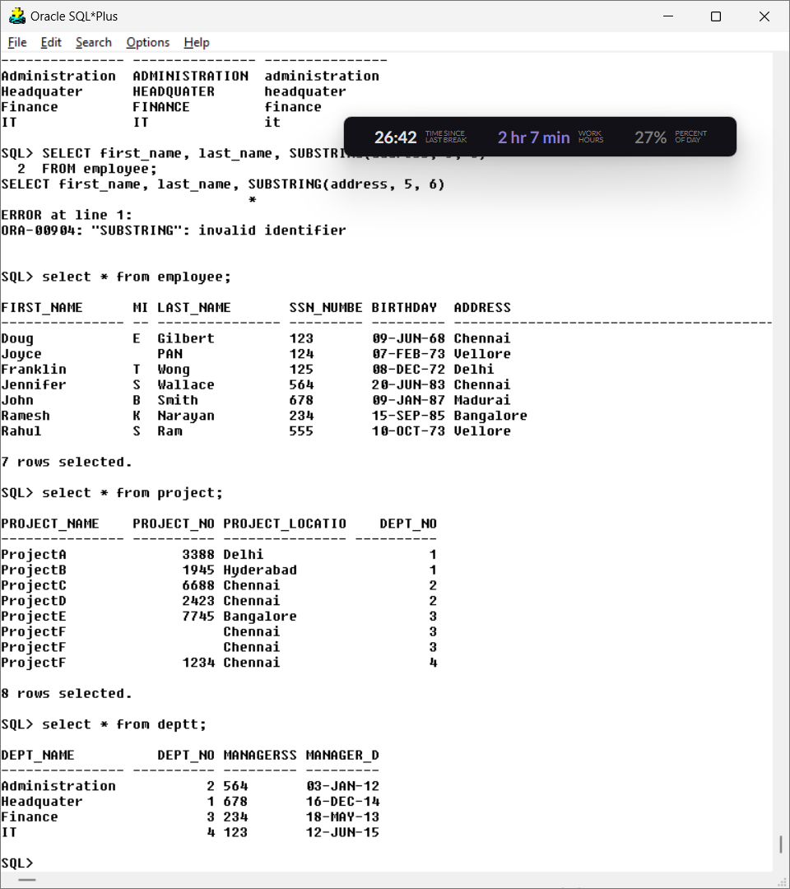

1. **Display the employee names whose bdate is on or before 1978.**

**Query:**

Select * from employee where birthday<(’01-JAN-1978’);

Output:

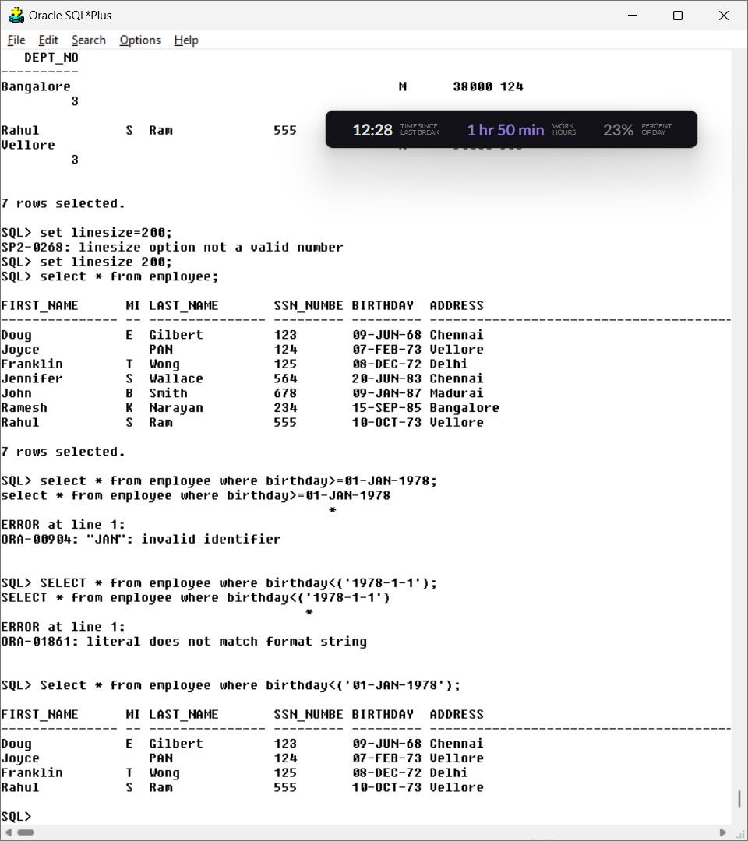

1. **Display all the department names in upper case and lower case.**

**Query**: SELECT dept_name, UPPER(dept_name), LOWER(dept_name)

FROM deptt;

**Output:**

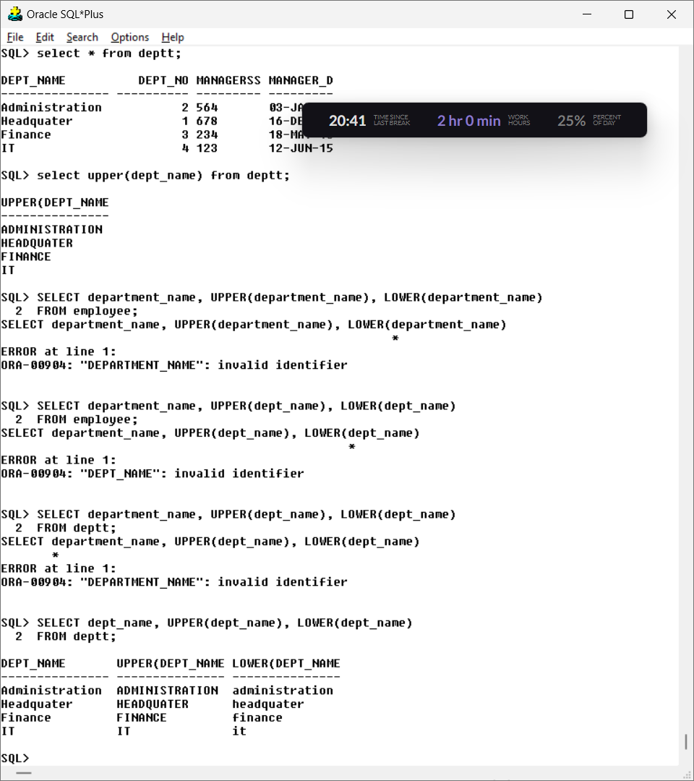

**3. Display the first four characters and last four of the department names using substring function.**

**Query:** select substr(dept_name,1,4), substr(dept_name,-4) from deptt;

**Output**:

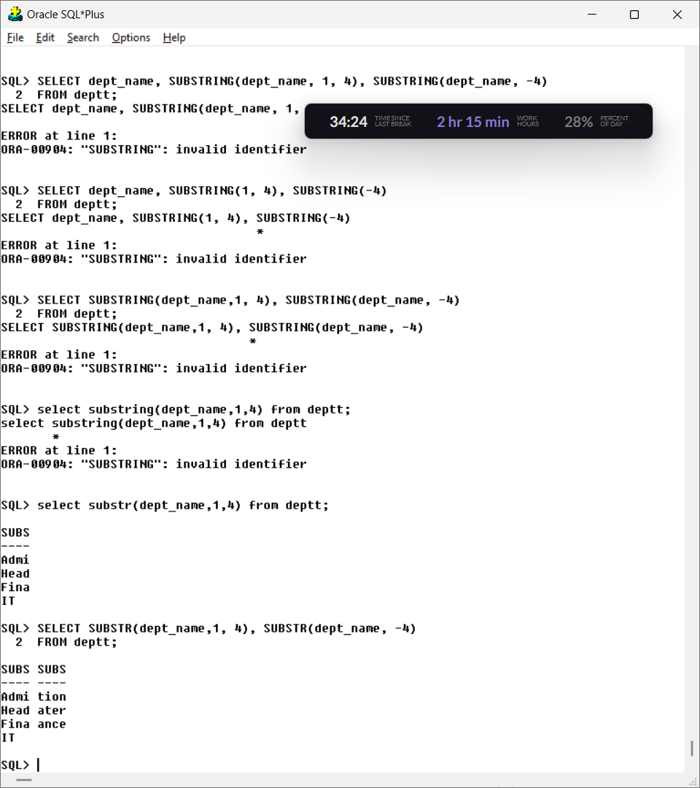

**4. Display the substring of the Address (starting from 5th position to 11 th position) of all employees.**

**Query:**

Select substr(address,5,11) from employee;

**Output:**



5**. Display the Mgrstartdate on adding three months to it.**

**Query:**

Select add_months(manager_doj,3) from deptt;

**Output:**

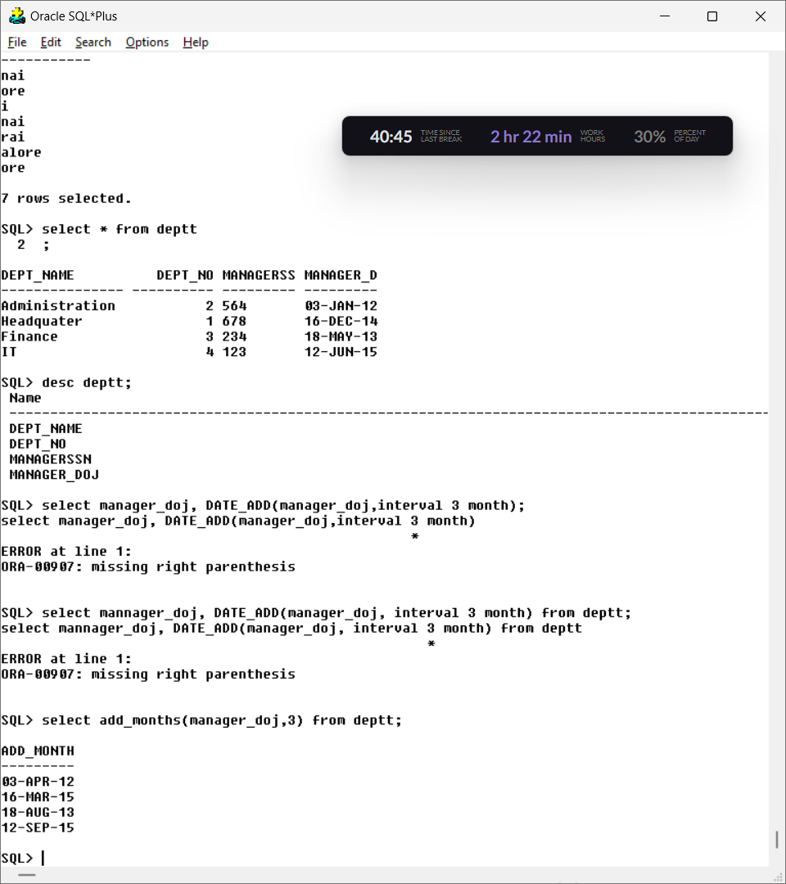

**6. Display the age of all the employees rounded to two digits.**

**Query:** select abs(round((months_between(sysdate,birthday)/12),2)) from employee;

**Output:**

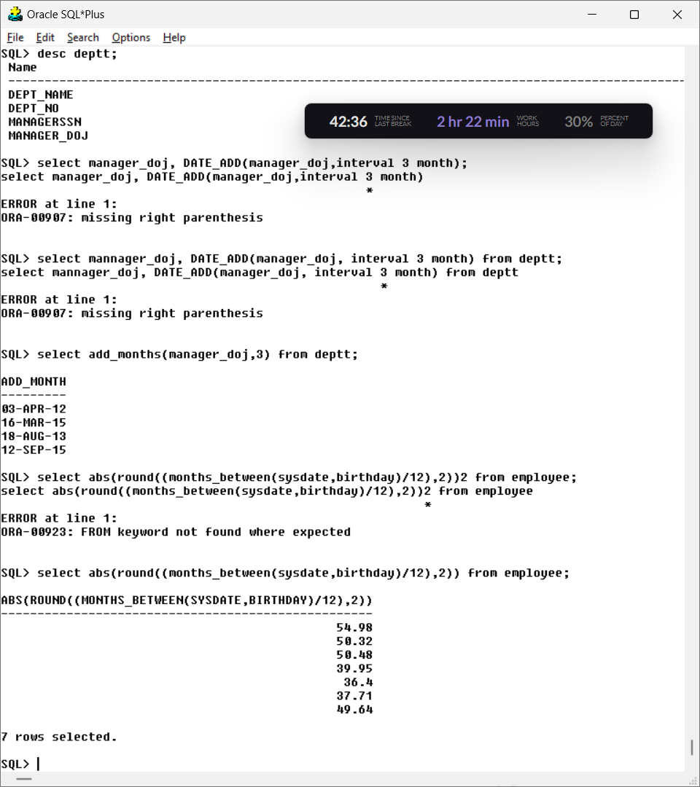

**7. Display the bdate of all employees in the format ‘DDthMonthYYYY’.**

**Query:** SELECT first_name, last_name, TO_CHAR(birthday, 'DDth Mon YYYY') AS birthday

FROM employee;

**Output:**

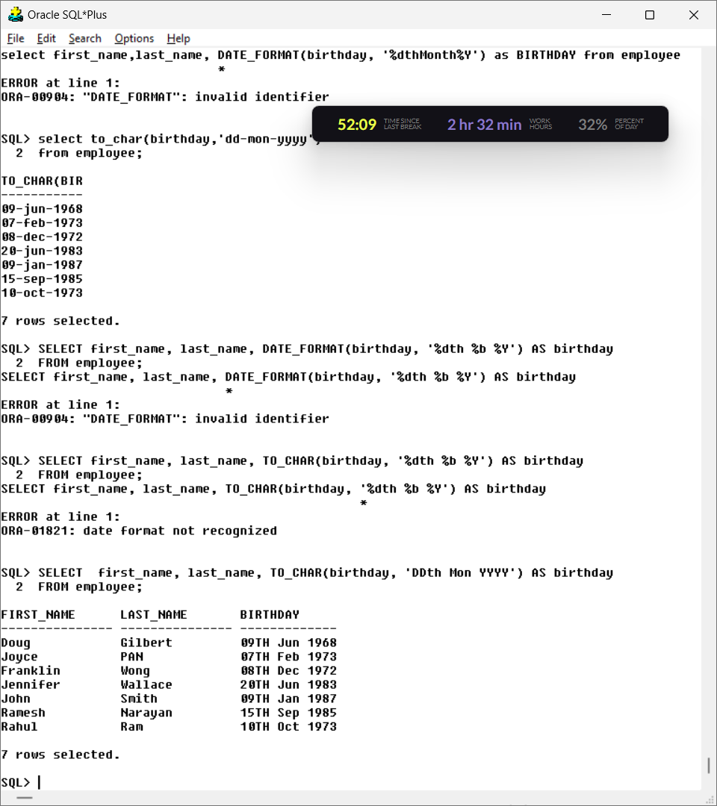

**8. Find the last day and next day of the month in which each manager has joined.**

**Query:**

Select manager_doj, last_Day(manager_Doj) from deptt;

**Output:**

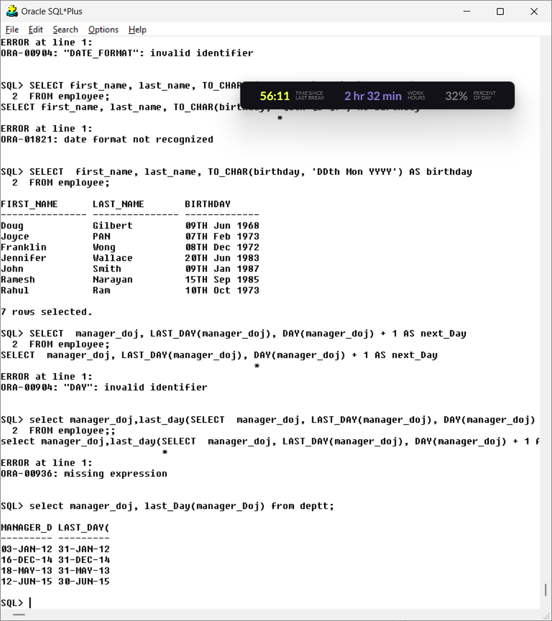

**9. Print a substring from the string ‘Harini’.**

**Query:**

Select substr(‘harini’,1,4) from dual;

**Output:**

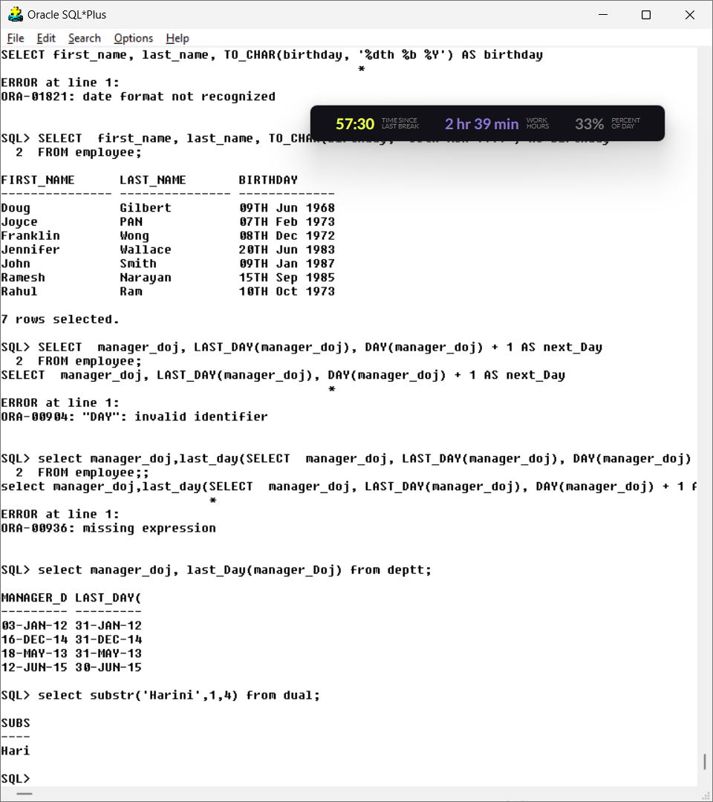

**10. Replace the string ‘ni’ from ‘Harini’ by ‘sh’.**

**Query:** select replace('harini','ni','sh') from dual;

**Output:**

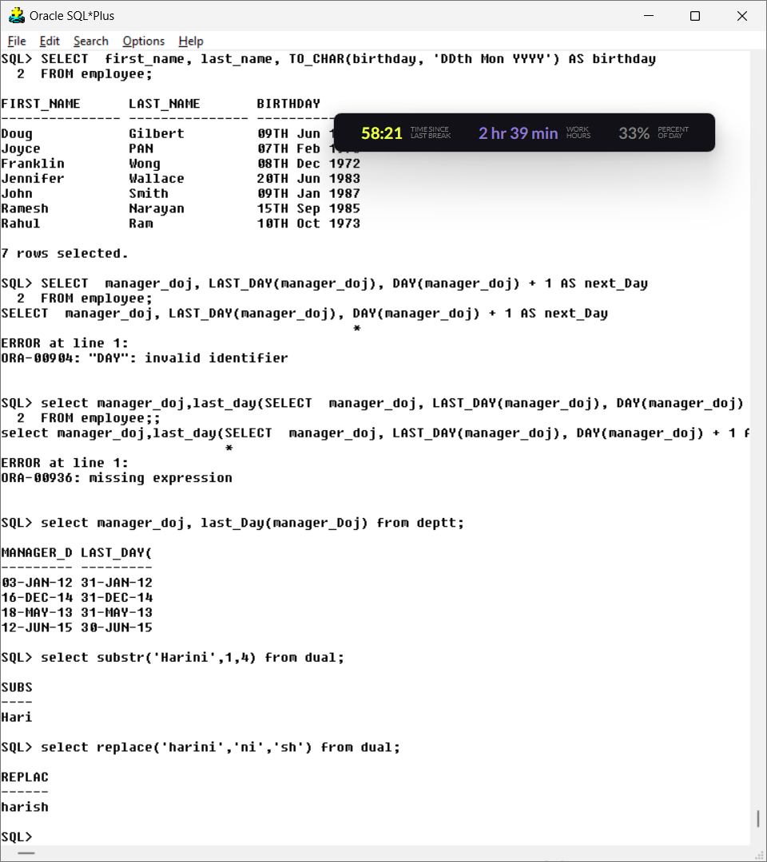

**11. Print the length of all the department names.**

**Query:** select length(dept_name) from deptt;

**Output:**

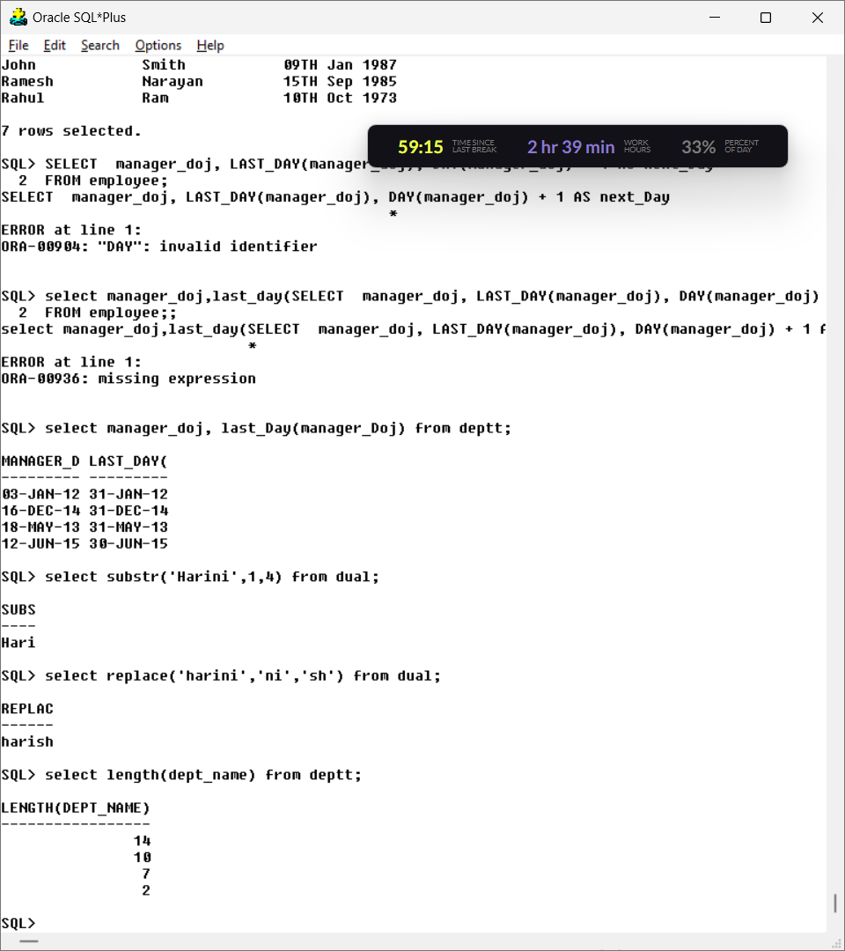

**12. Display the date after 10 months from current date.**

**Query**:

Select add_months(sysdate,10) from dual;

**Output:**

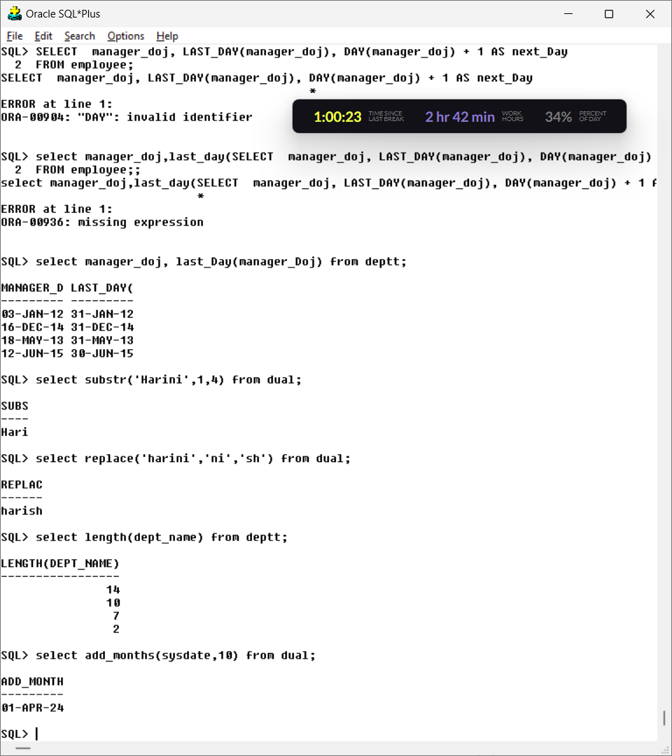

**13. Display the next occurrence of Friday in this month.**

**Query:**

Select next_day(sysdate,’friday’) from dual;

**Output:**

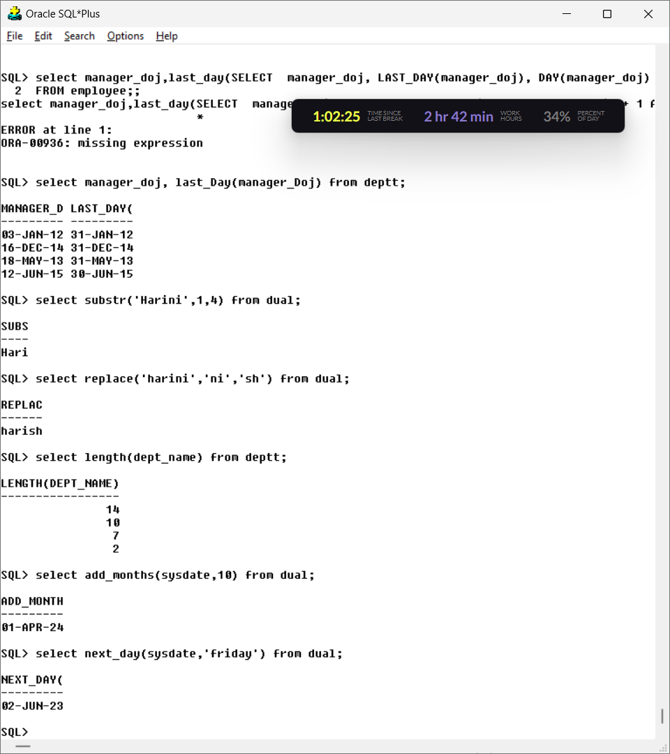

**14. Display the project location padded with **** on left side.**

Query: select Lpad(project_location,length(project_location)+3,'****') from project;

**Output:**

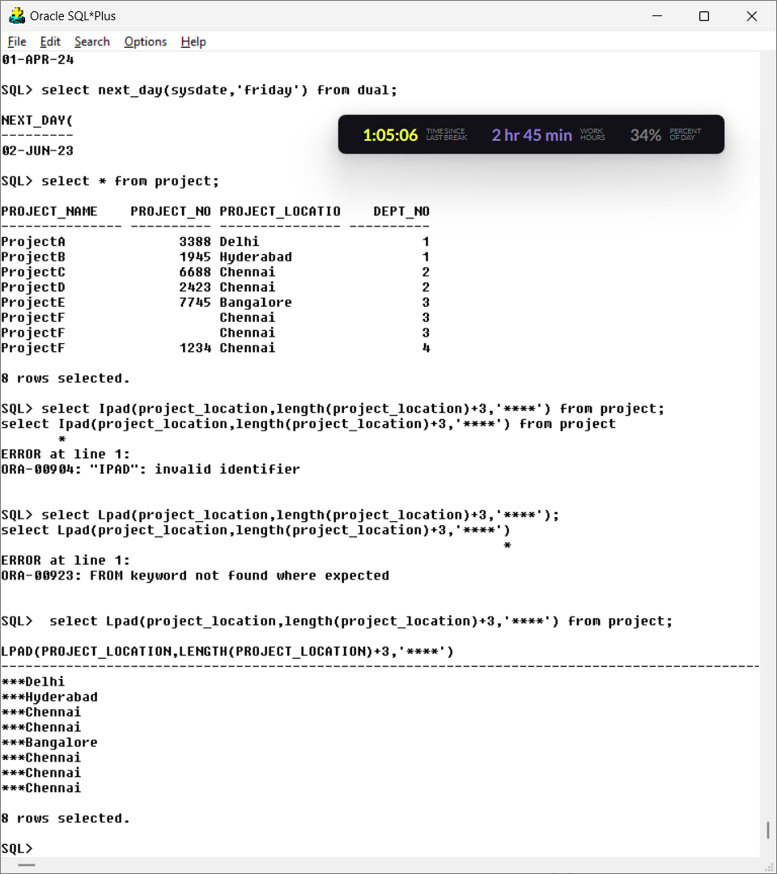

**15. Display the day of next Saturday.**

**Query:**

Select next_day(sysdate, ‘Saturday’) from dual;

**Output:**

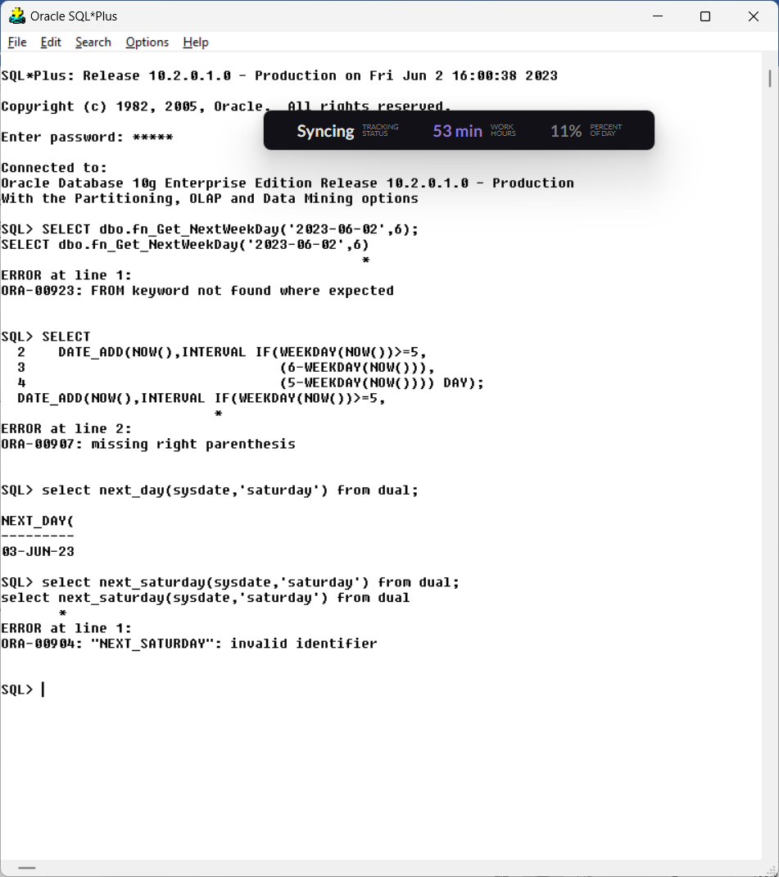

**16. Display the last date of Feb 2022.**

Query: select last_day(’01-Feb-2022’) from dual;

**Output:**

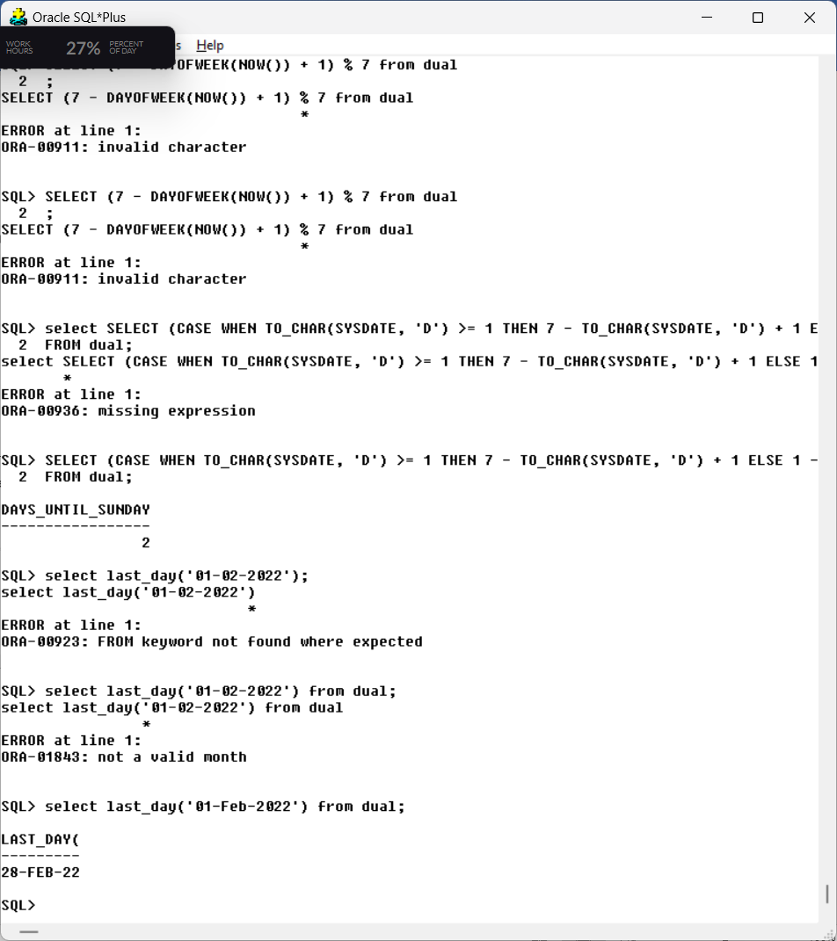

**17. Count the number of days present between today and Sunday.**

**Query:**

SELECT (CASE WHEN TO_CHAR(SYSDATE, 'D') >= 1 THEN 7 - TO_CHAR(SYSDATE, 'D') + 1 ELSE 1 - TO_CHAR(SYSDATE, 'D') END) AS days_until_Sunday from dual;

**Output:**

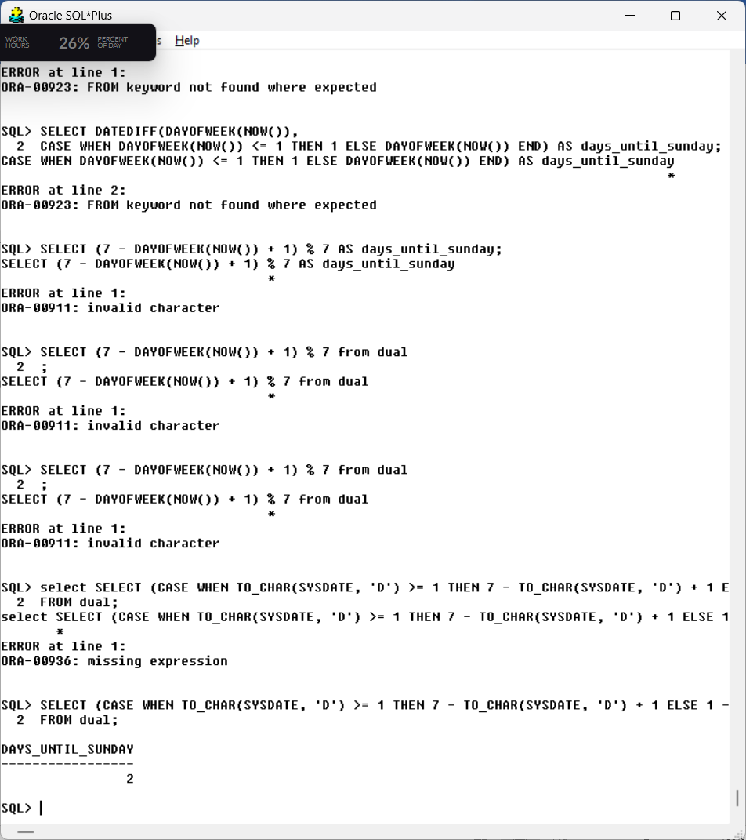

**18. Display all the employees whose experience is greater than 14 yrs.**

**Query:**

Select Manager_doj, First_Name from Employee natural join Deptt where (months_between(sysdate, Manager_doj) /12)>14;

**Output:**

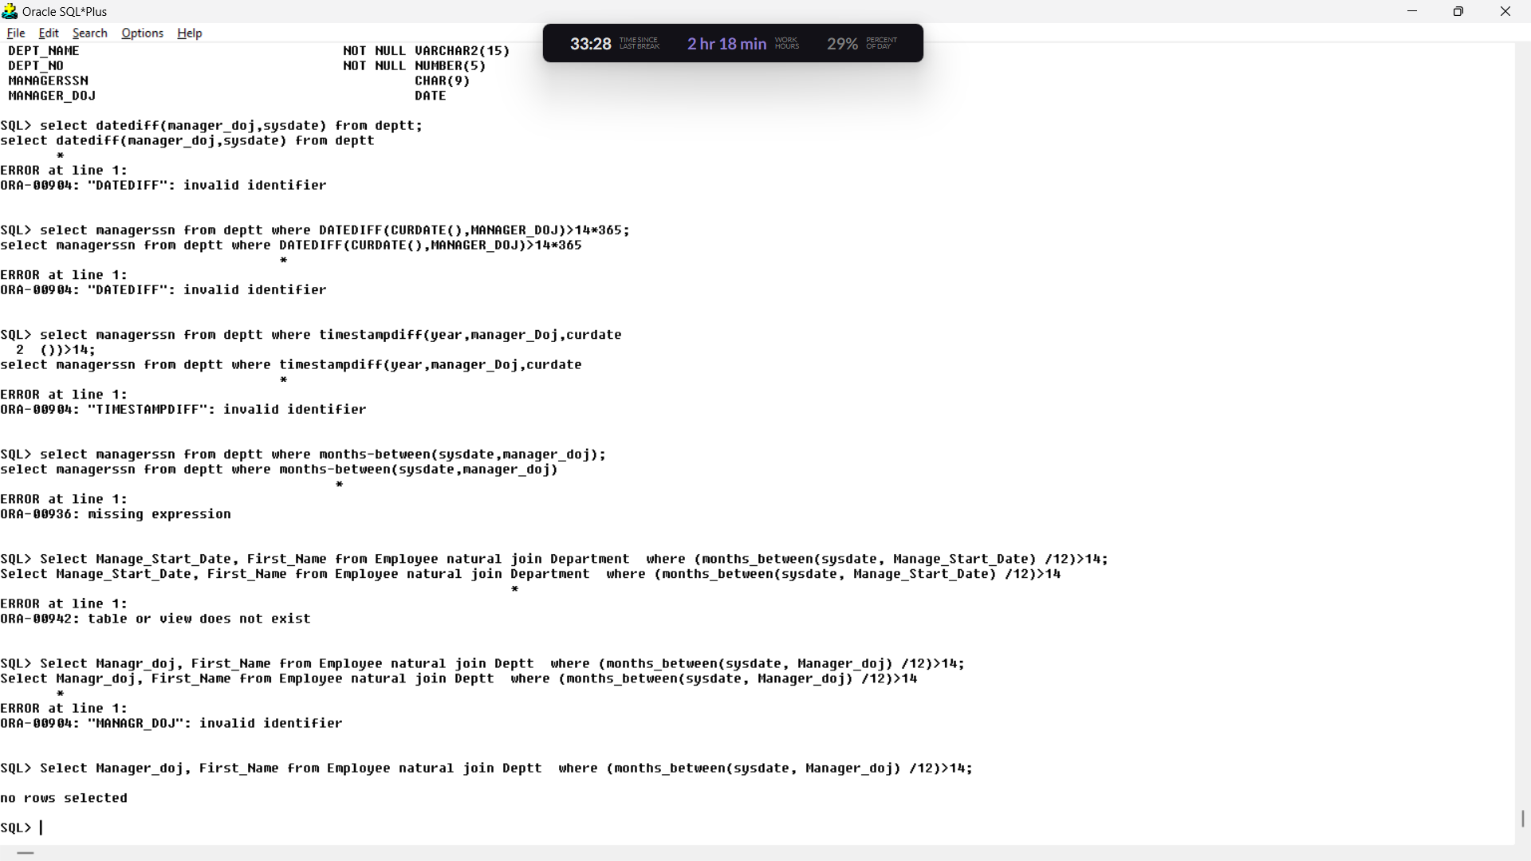

**Group Functions**

**19. Find the total salary of all employees**

**Query:** Select sum(salary) from employee;

**Output:**

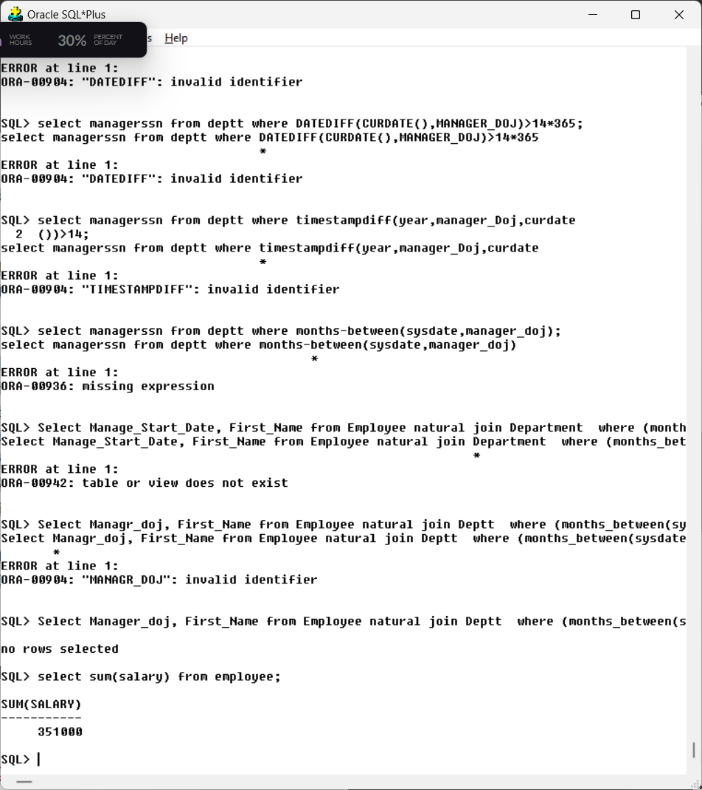

**20. Display the min, max salary given to employees**

**Query:** select max(salary),min(salary) from employee**;**

**Output:** 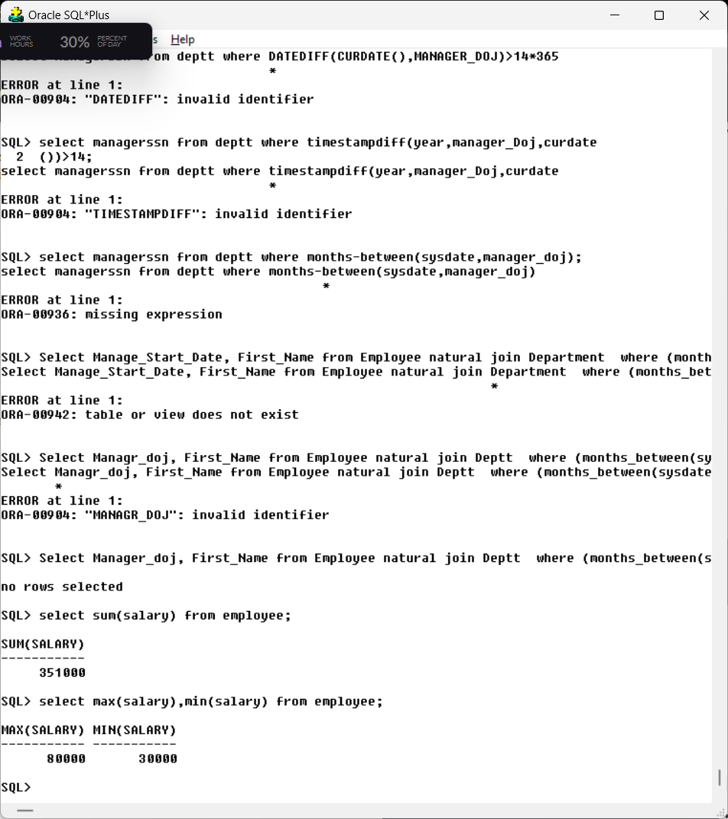

**21. Display the avg salary of all employees**

**Query:** Select avg(salary) from employee;

**Output:**

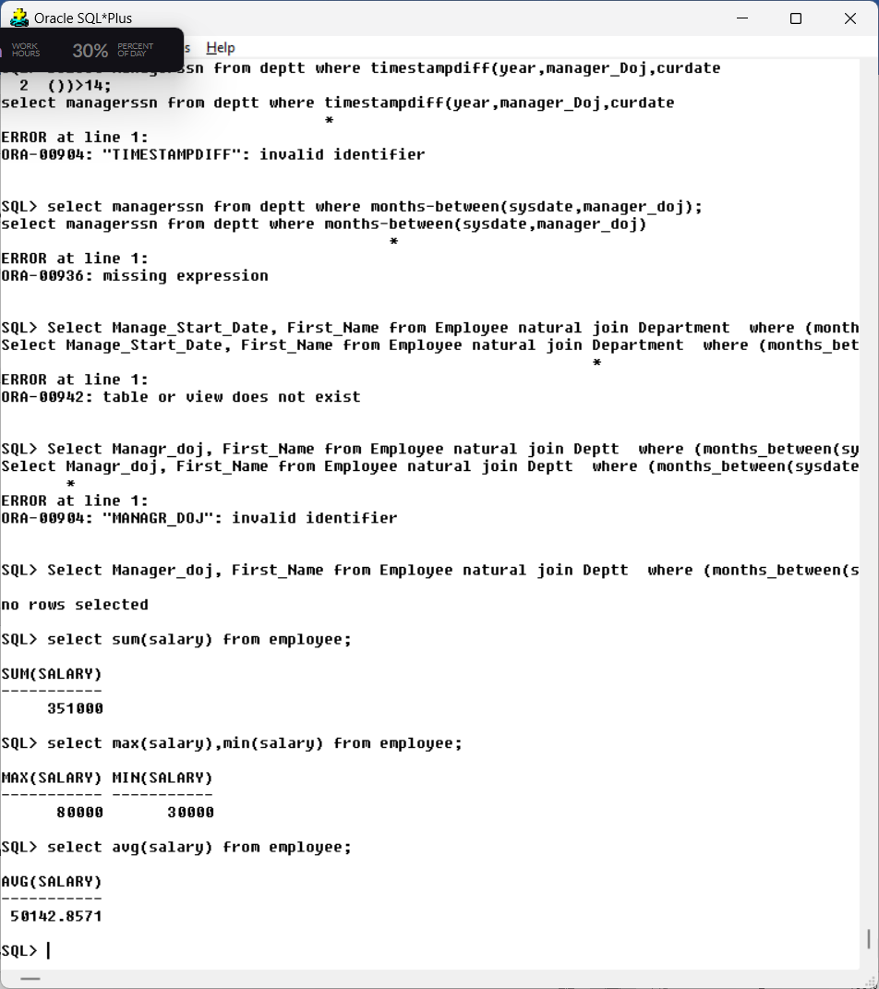

**22. Display the total number of employees**

**Query:** select count(first_name) from employee;

**Output:**

‘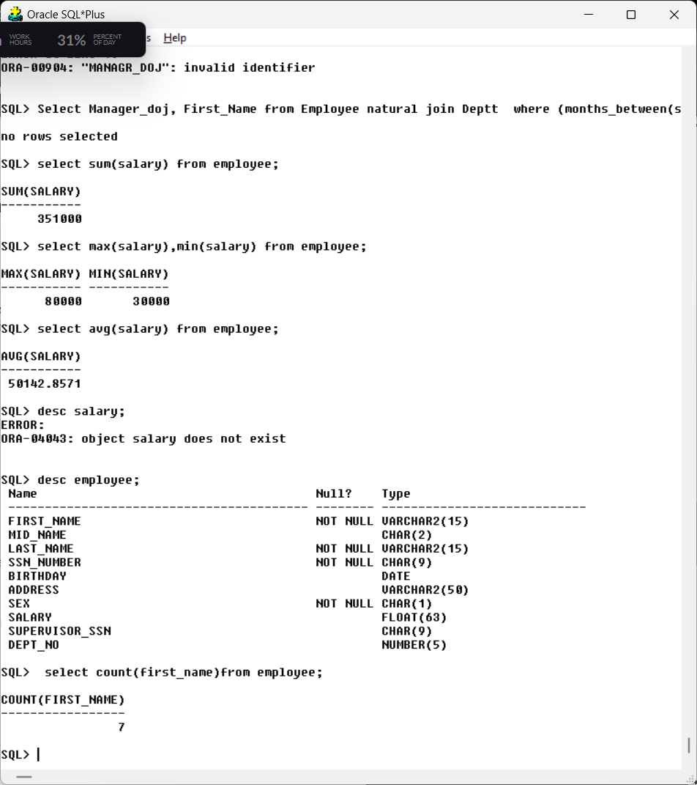

**23. How many different departments are there in the ‘employee’ table**

**Query:** select count(dept_no) from employee;

**Output:**

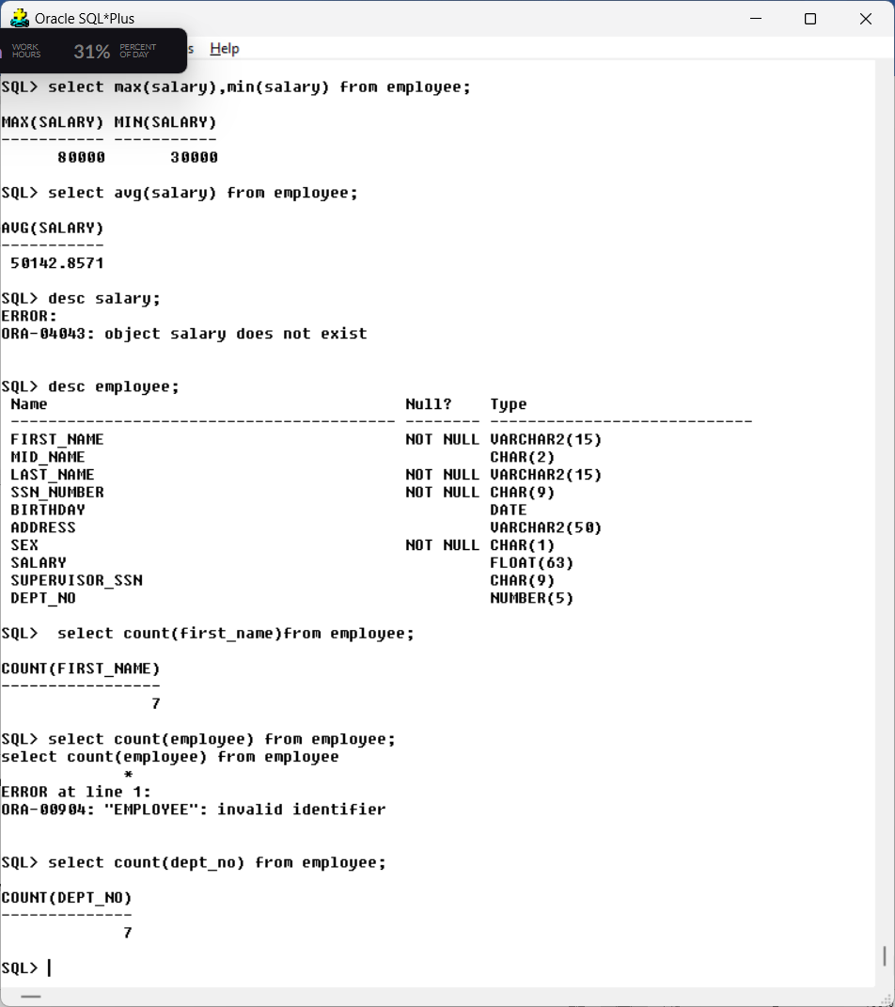

**24. For each department display the minimum and maximum employee salaries**

**Query:** select dept_no, min(salary) , max(salary) from employee group by dept_no;

**Output:**

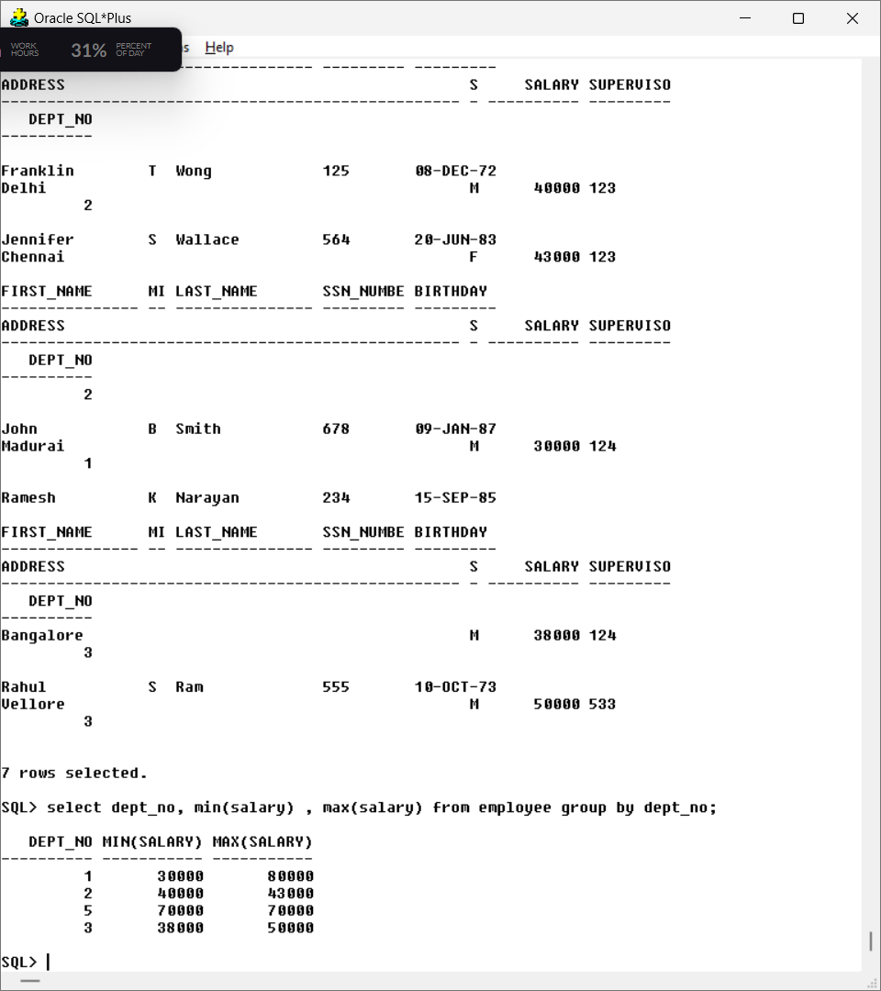

**25. Print the average annual salary.**

**Query:** select avg(salary)*12 from employee;

**Output:**

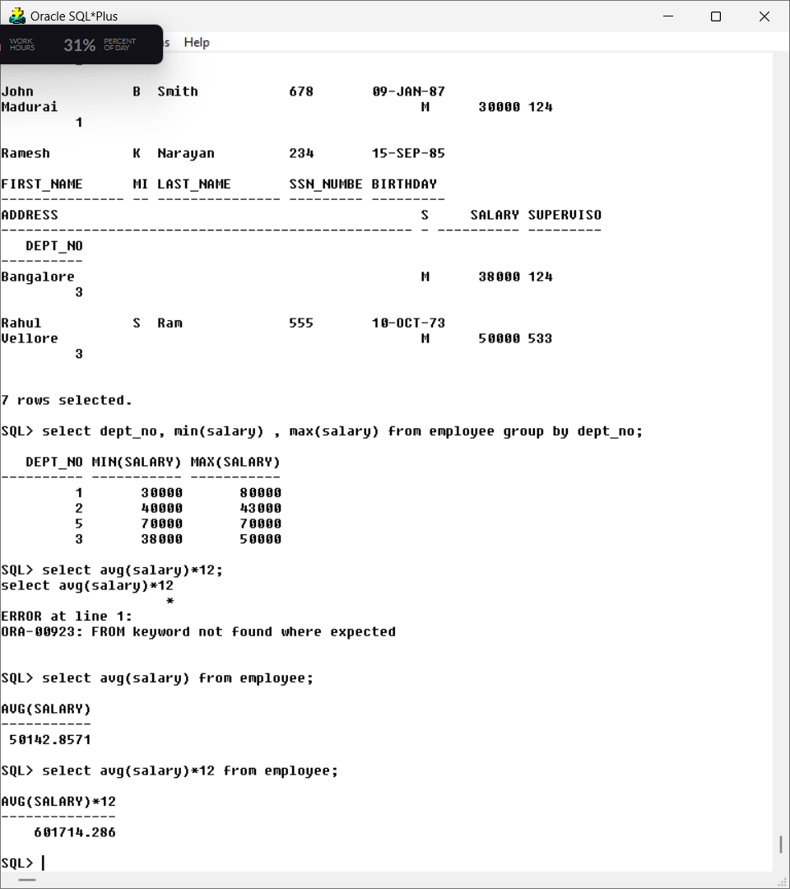

**26. Count the number of employees over 30 age.**

**Query:** select count(*) from employee where(months_between(sysdate,birthday))>30*12;

**Output:**

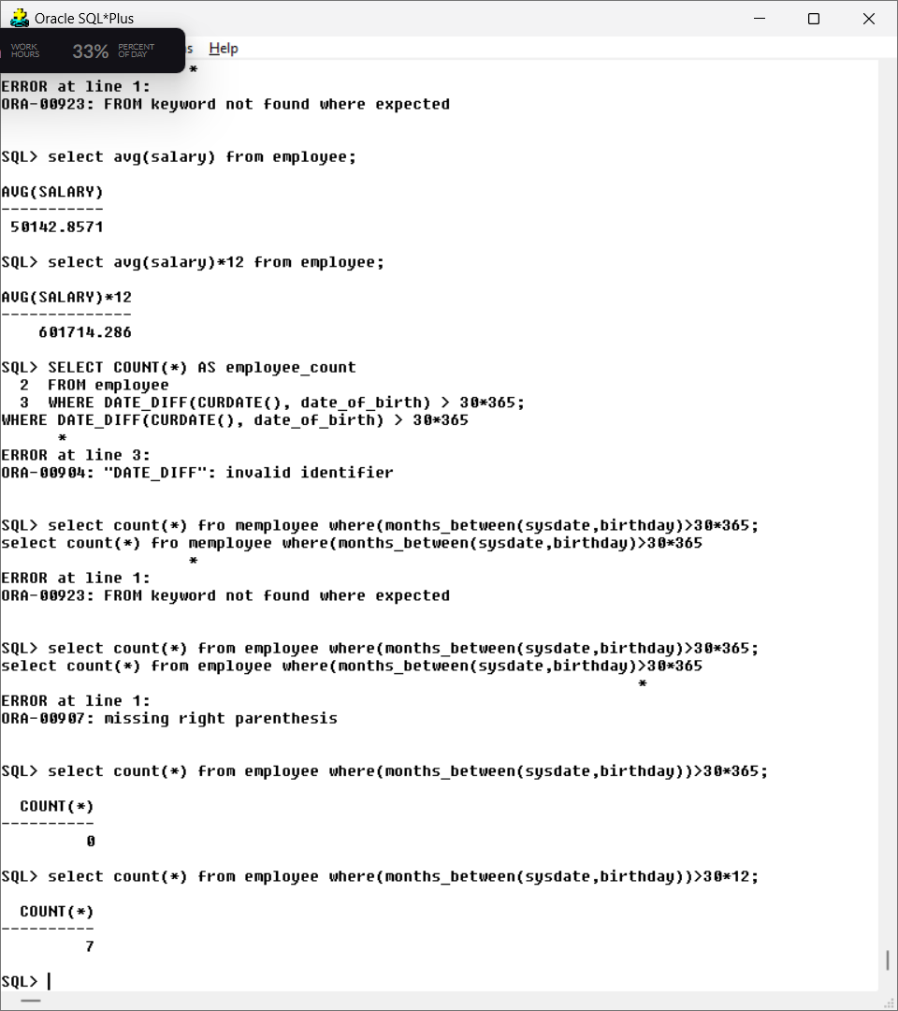

**27. Print the Department name and average salary of each department.**

**Query:** select d.dept_name, avg(e.salary) from deptt d

join employee e ON d.dept_no=e.dept_no

group by d.dept_name;

**Output:**

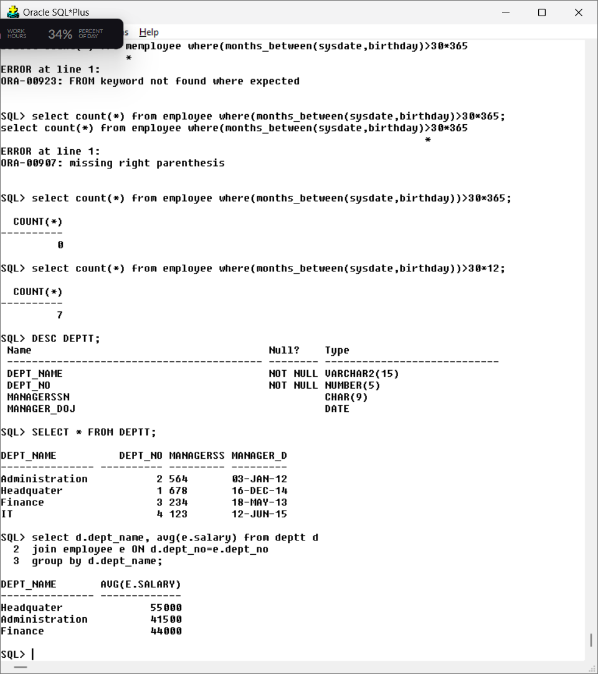

**28. Display the department name which contains more than 2 employees.**

**Query:** select d.dept_name from deptt d

join employee e ON d.dept_no=e.dept_no

group by d.dept_name

having count(*)>2;

**Output:**

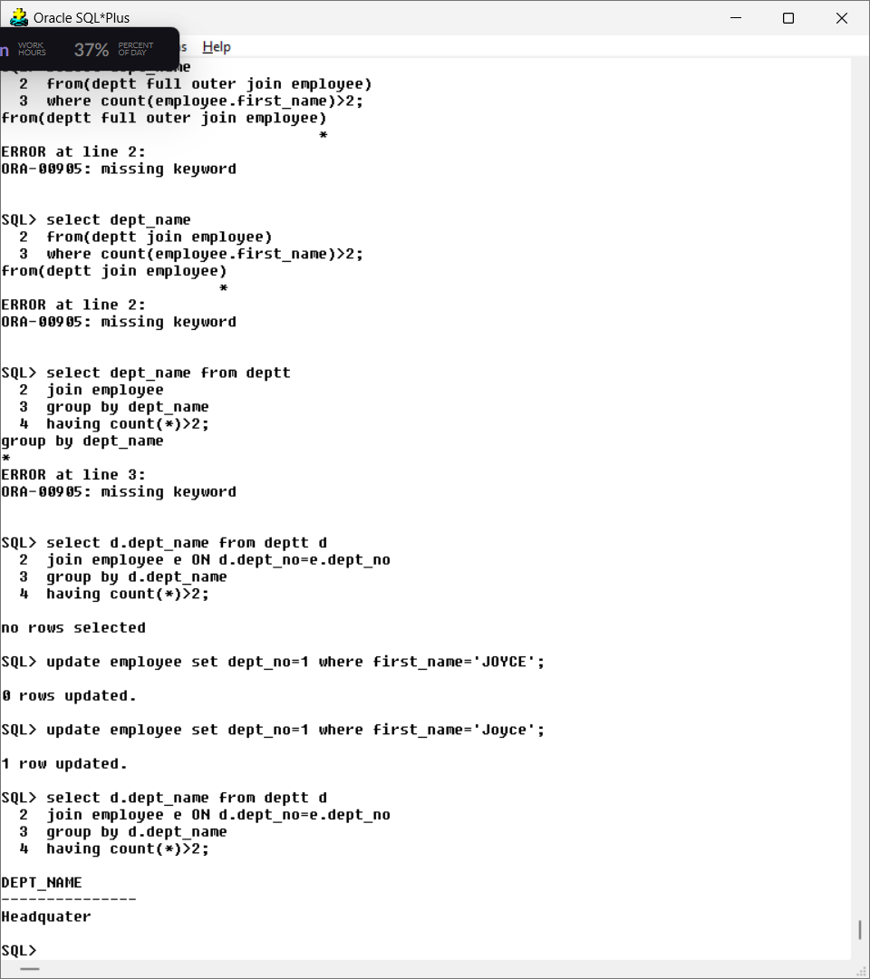

**29. Calculate the average salary of employees by department and age**

**Query:** select dept_no, avg(salary) from (employee natural join deptt) group by dept_no;

**Output:**

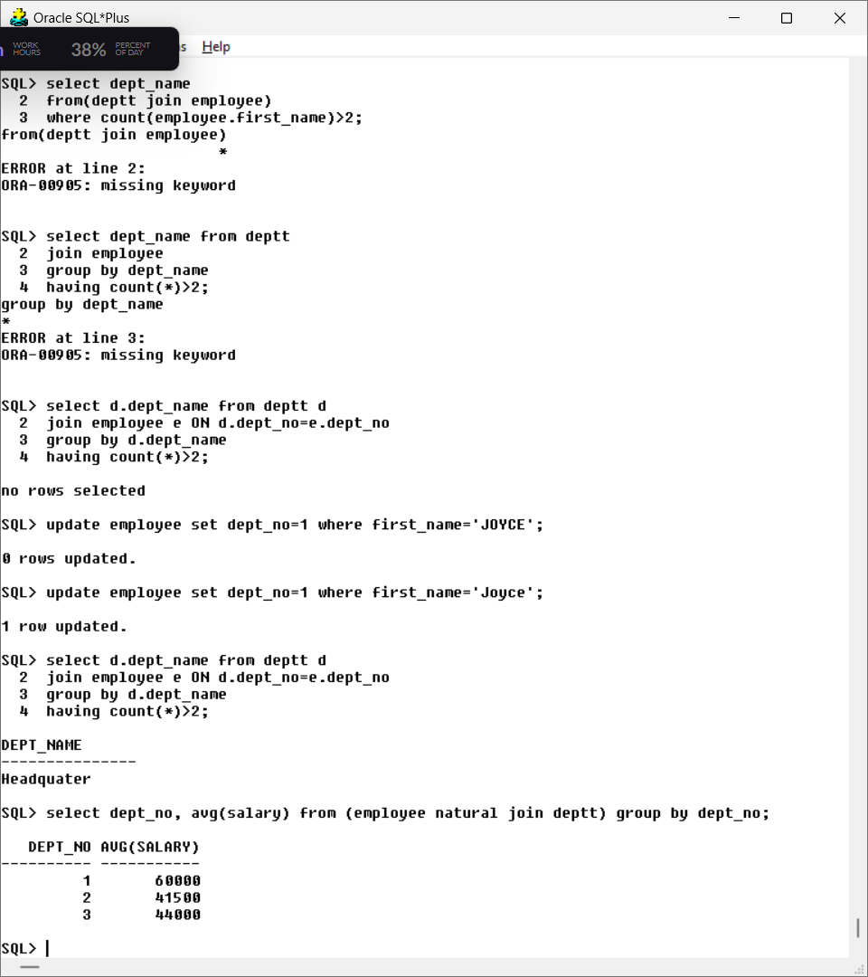

**30. Count separately the number of employees in the finance and administration department.**

**Query:**

select first_name from(employee natural join deptt) where dept_name='Finance';

select count(*) from (employee natural join deptt) where dept_name='Finance';

select first_name from(employee natural join deptt) where dept_name='Administration';

select count(*) from (employee natural join deptt) where dept_name='Administration';

**Output:**

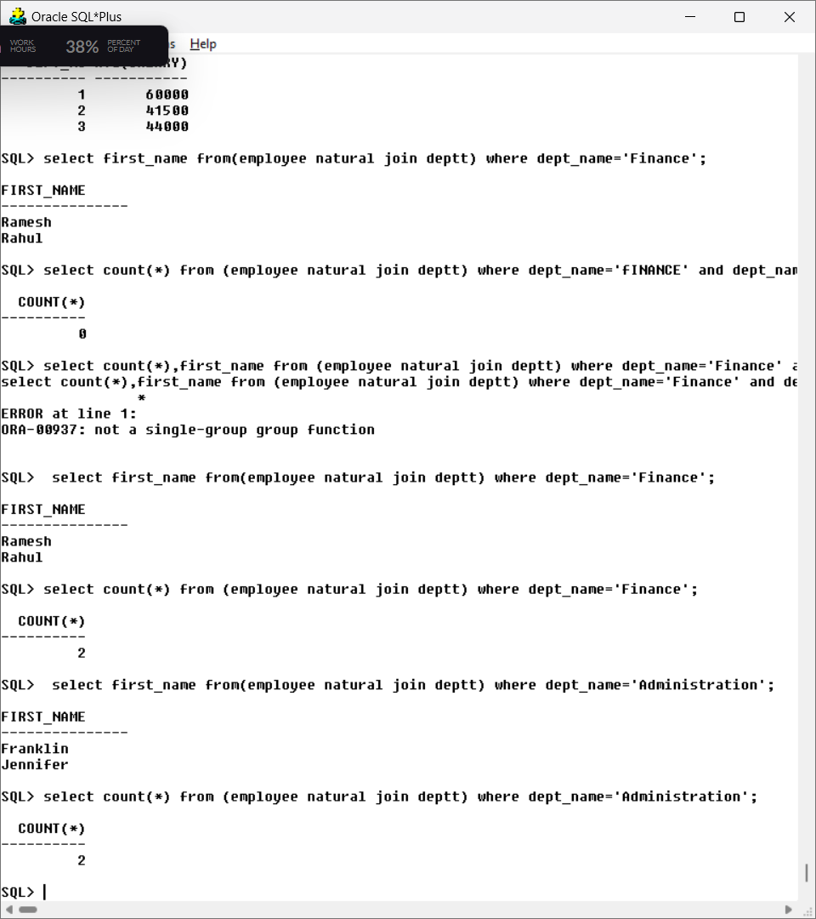

**31. List out the employees based on their seniority.**

**Query:** select first_name,round(months_between(sysdate,manager_doj))as experience, dept_name from (employee natural join deptt) where deptt.managerssn=employee.ssn_number order by experience;

**Output:**

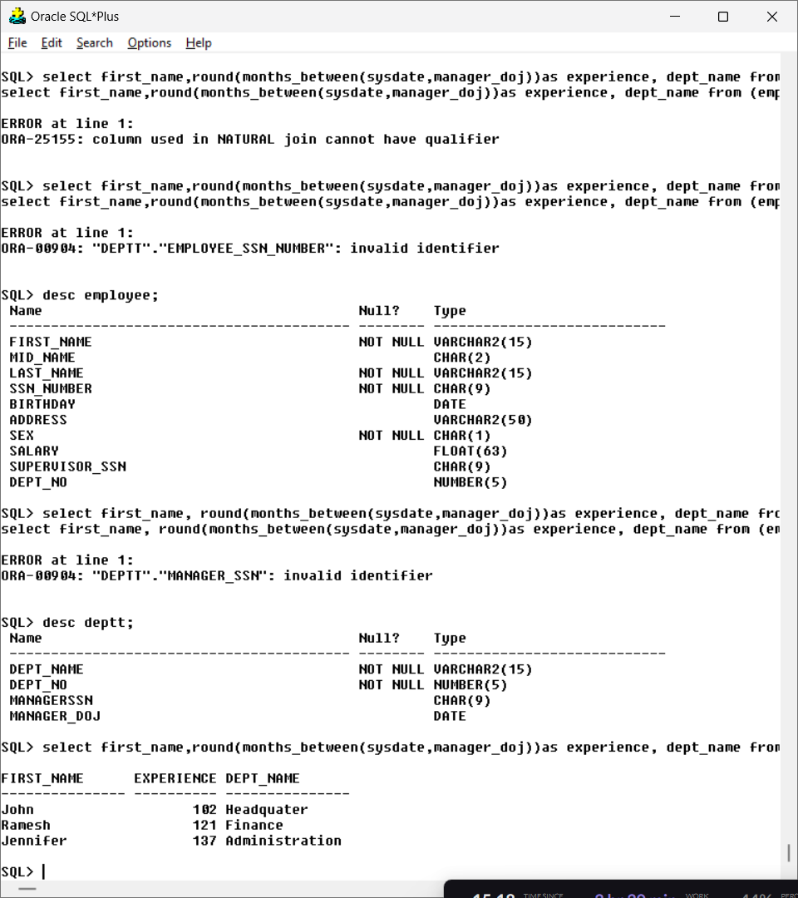

**32. Display the total number of employees who are assigned to a department.**

**Query:** select dept_no, count(*) from (Deptt natural join Employee) group by dept_no;

**Output:** 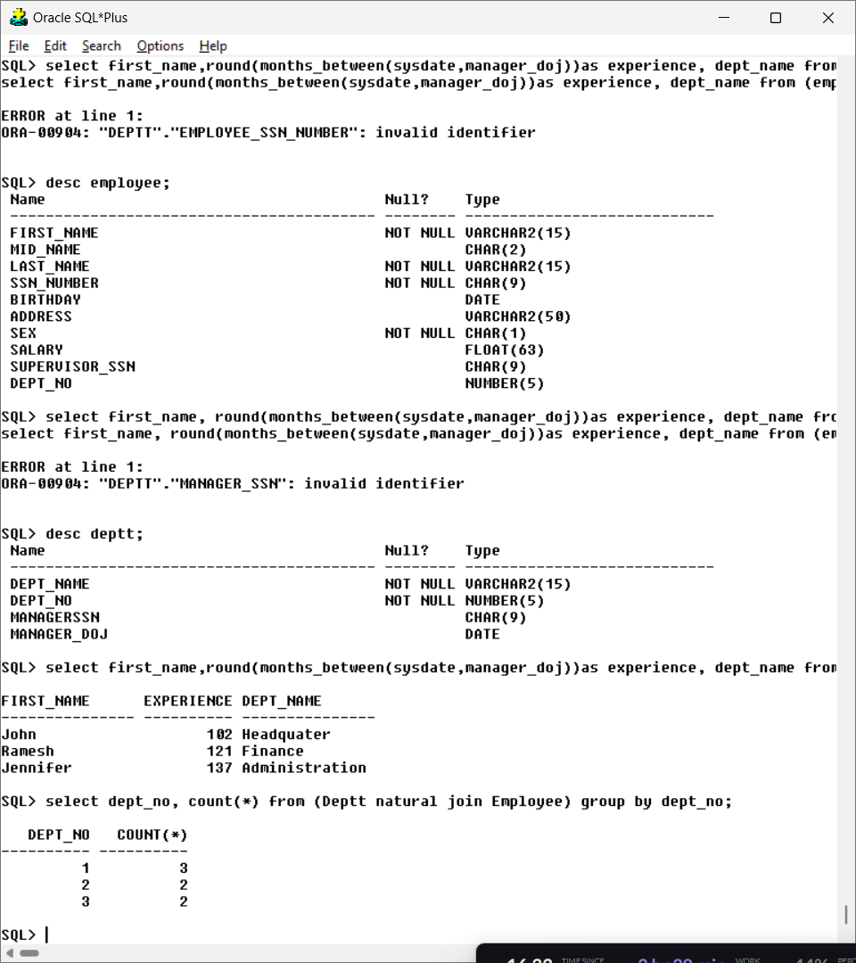

**33. Display only department numbers that are paying a total salary of more than 30000 to its**

**Employees**

**Query:** select dept_no,sum(salary) from employee group by dept_no having sum(salary)>30000;

**Output:**

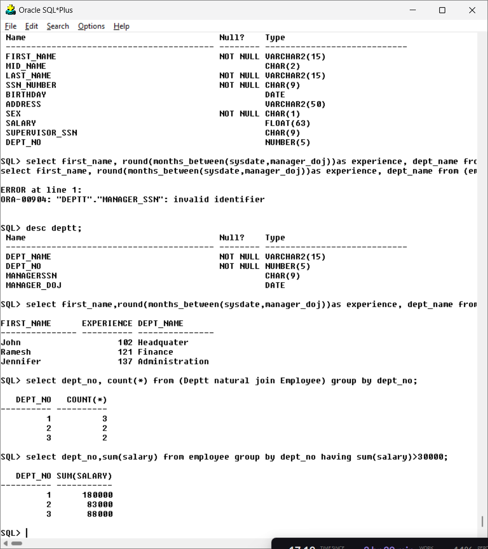**34. Display all the employees working under the department 1.**

**Query:** select first_name, dept_no from employee where dept_no=1;

**Output:**

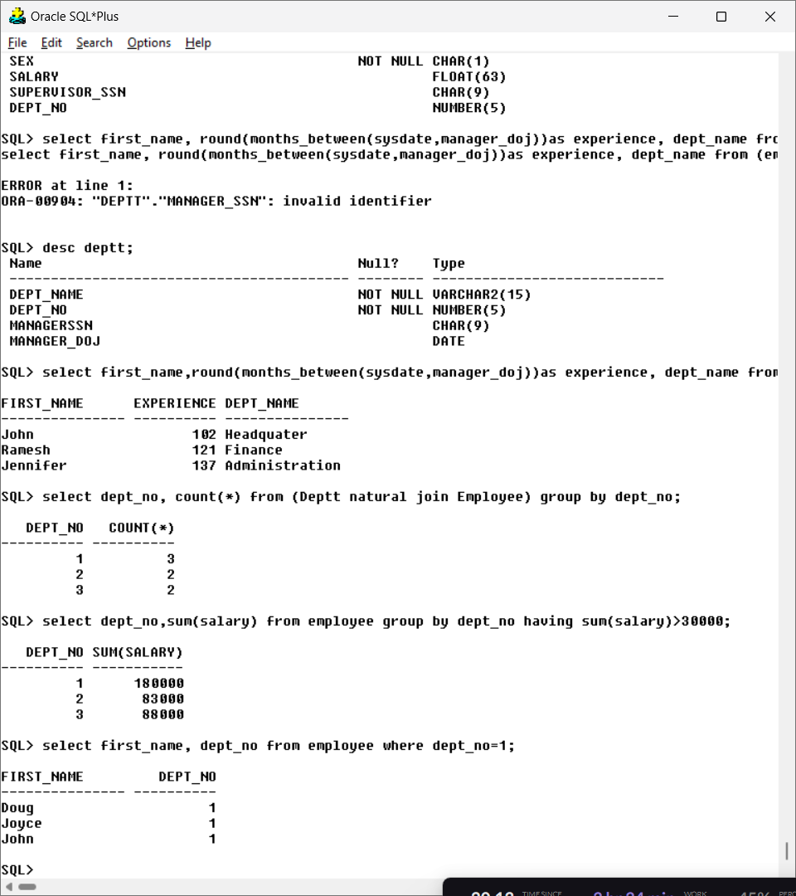

**35. Display employees whose salary is between 5000 and 10000 in department no 1.**

**Query:** select first_name, dept_no, salary from employee where dept_no=1 and salary>5000 and salary<1000;

**Output:**

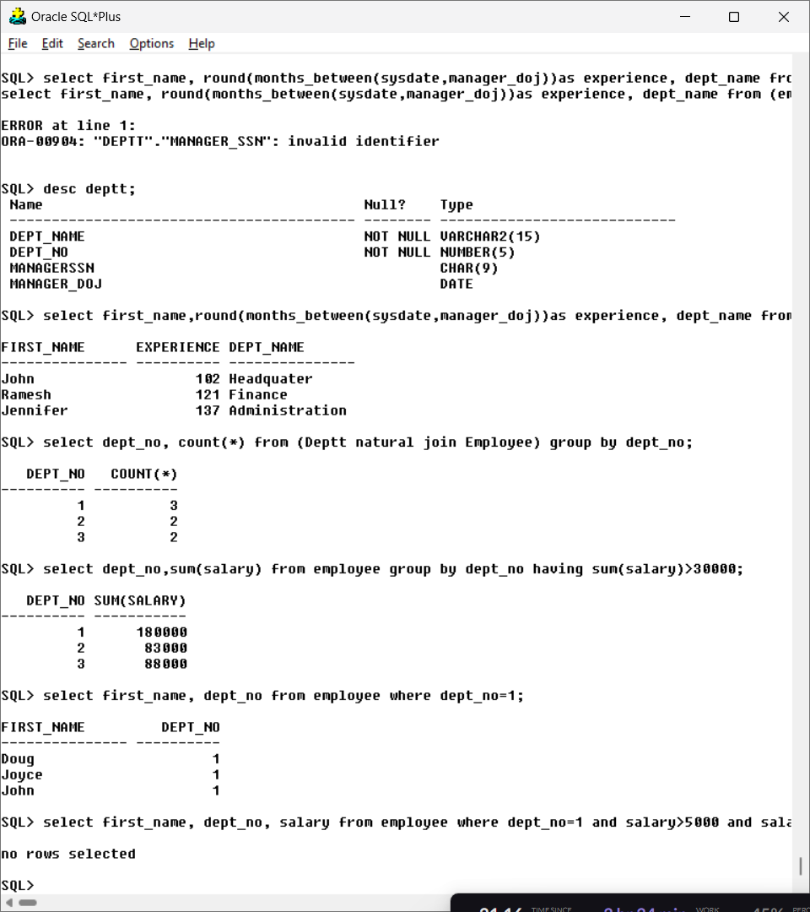

**SUB QUERY AND VIEW IN SQL**

**Aim: To understand different types of function in SQL**

**Consider the schema (used in EX2):**

1. **Find the employee who is getting highest salary in the department headquarters.**

**Query:** select first_name,dept_name, Salary from(Employee natural join deptt) where salary=(select max(salary) from employee) and dept_name='Headquater';

**Output:**

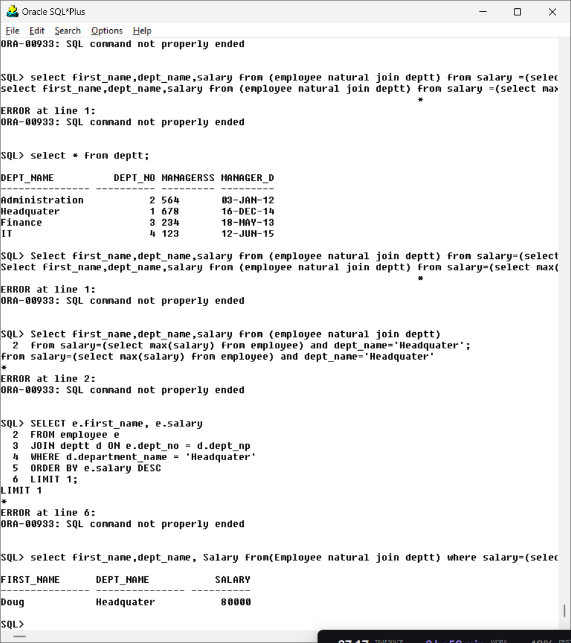

1. **Find the employees who earn the same salary as the minimum salary for each Department.**

**Query:**

Select First_Name, Dept_name,Dept_No, Salary from (Employee natural join Deptt) where Salary in(Select min(Salary) from Employee group by Dept_No);

**Output:**

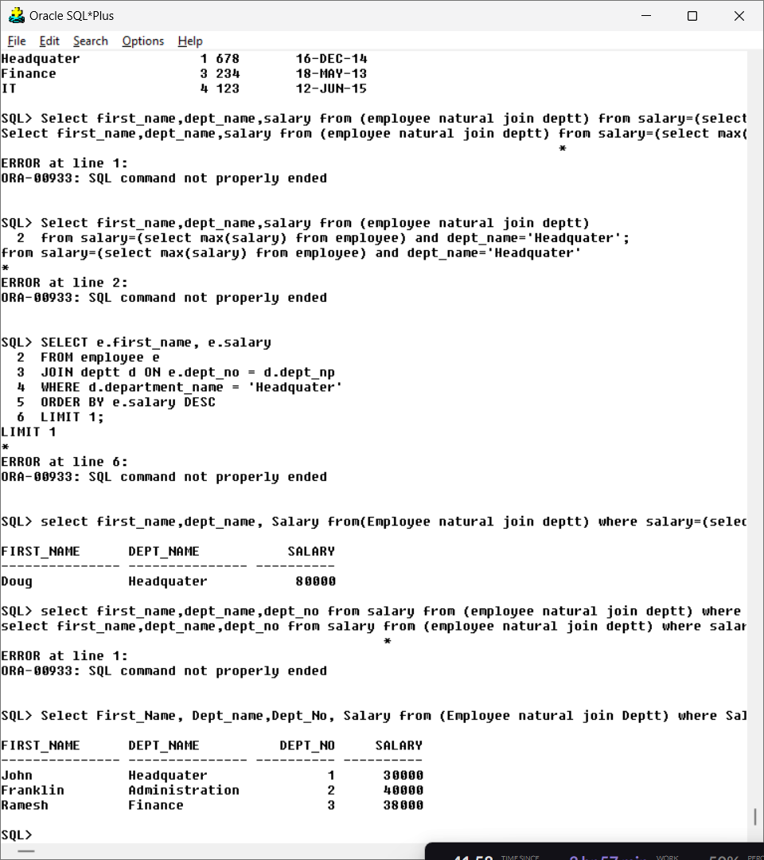

1. **Find the employee whose salary is greater than average salary of department 2.**

**Query:**

Select First_Name, Dept_Name, Dept_No, Salary from (Employee natural join Deptt) where Salary > (Select avg(Salary) from Employee where Dept_No = 2);

**Output:**

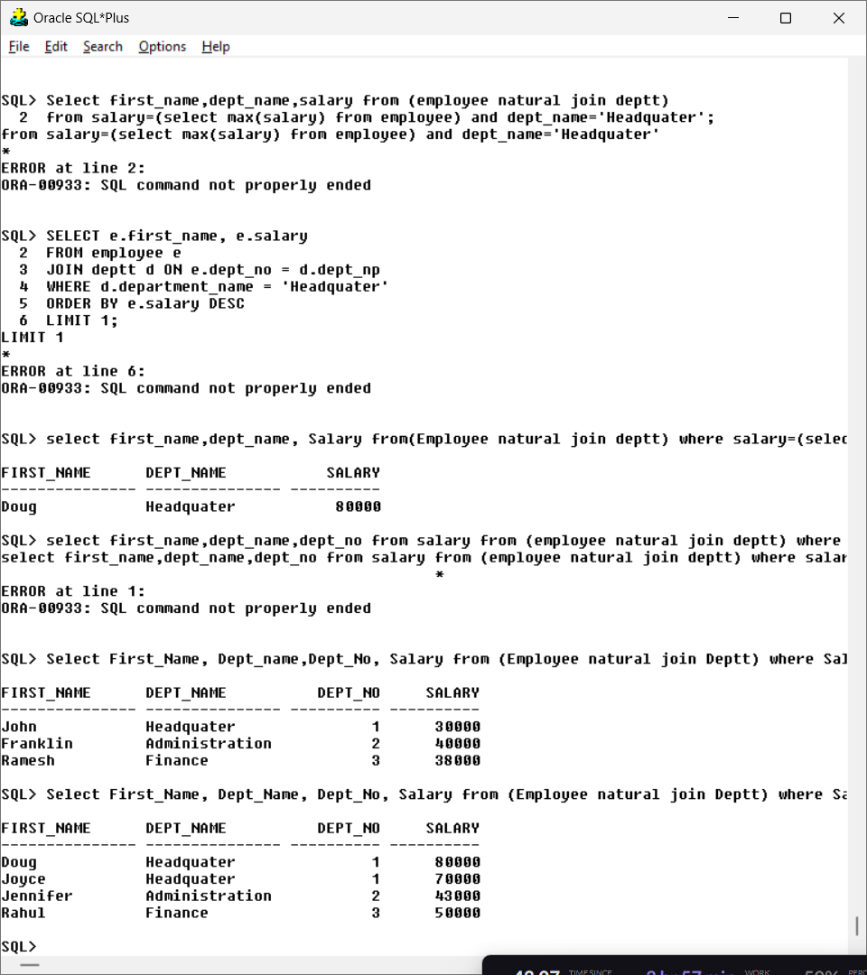

1. **List out all the department names with their individual employee’s strength.**

**Query:**

Select Dept_Name, Dept_No, count(*) from (Employee natural join Deptt) group by Dept_No, Dept_Name;

**Output:**

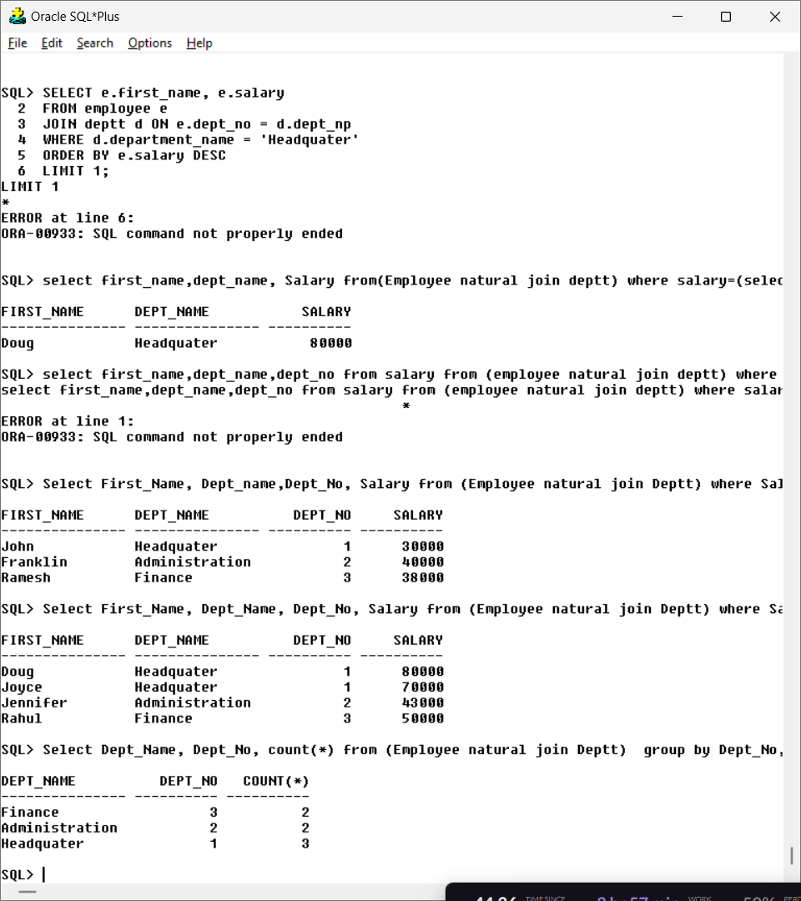

1. **Find out the department name having highest employee strength.**

**Query:** Select Dept_name, Dept_No from Deptt where Dept_No in (Select Dept_No from Employee group by Dept_No having count(*) in (select max(Employees) from (Select count(*) Employees from Employee group by Dept_no)));

**Output:**

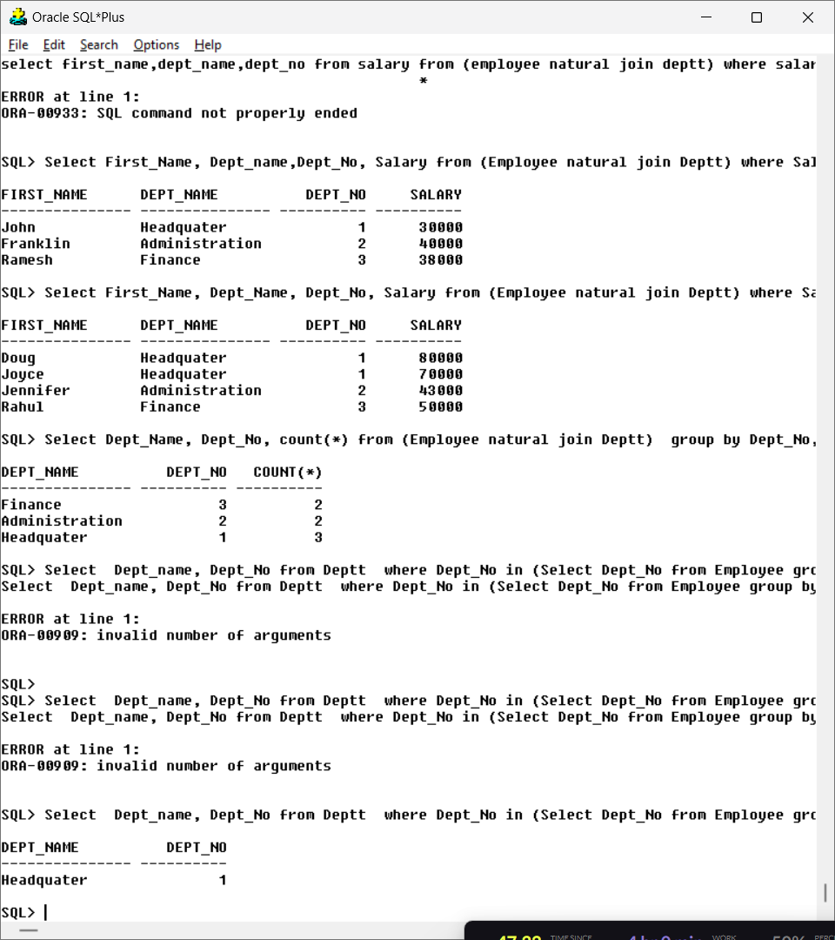

1. **List out all the departments and average salary drawn by their employees.**

**Query:** Select Dept_name, avg(Salary) from (Employee natural join Deptt) group by Dept_Name, Dept_No;

**Output:**

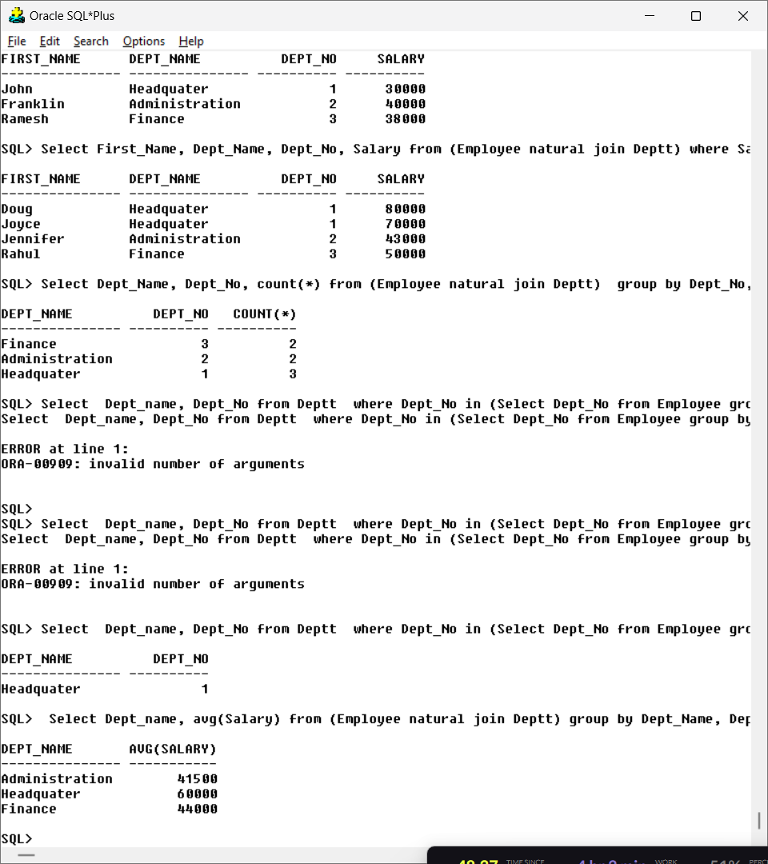

1. **Find average salary for each department.**

**Query:** Select Dept_name, avg(Salary) from (Employee natural join Deptt) group by Dept_Name, Dept_No;

**Output:**



1. **Create a view to display the employee details who is working in Administration department.**

**Query:** Create view Administration_Emp as Select * from Employee where Dept_No = (Select Dept_No from Deptt where Dept_Name = 'Administration');

Select * from Administration_Emp

**Output:**

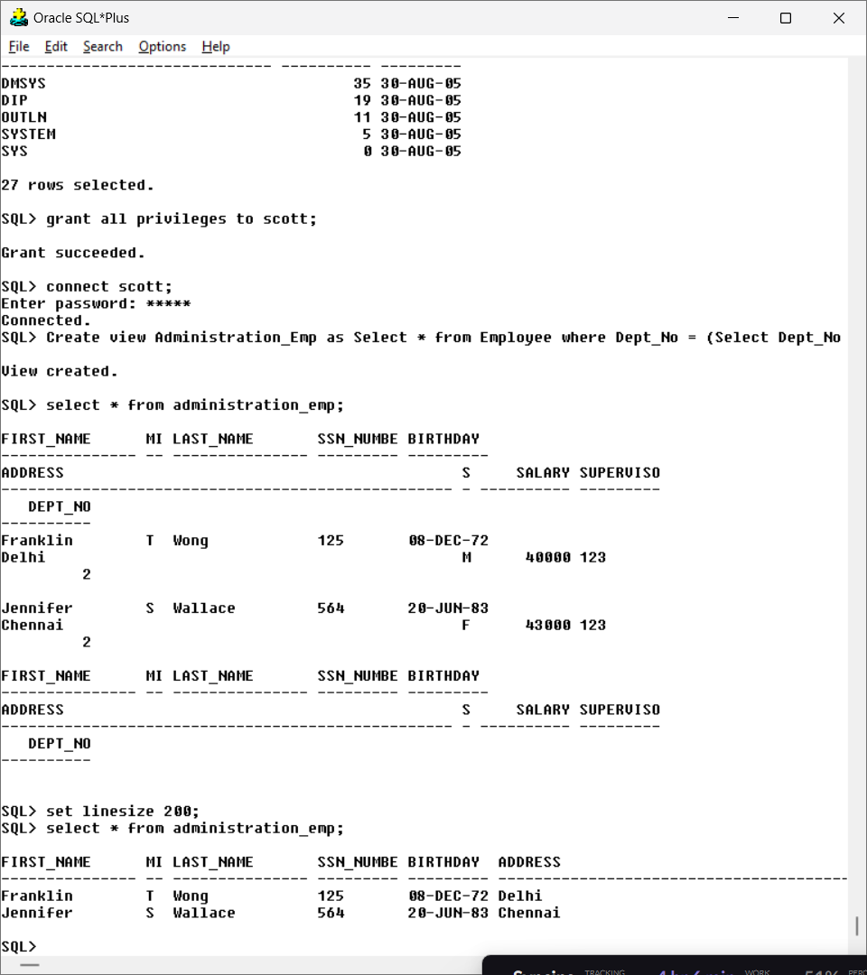

1. **Create a logical table to store employee details who is getting salary more than 10000.**

**Query:** Create view Salary10000 as Select * from Employee where salary>10000**;**

Select * from salary1000;

**Output:**

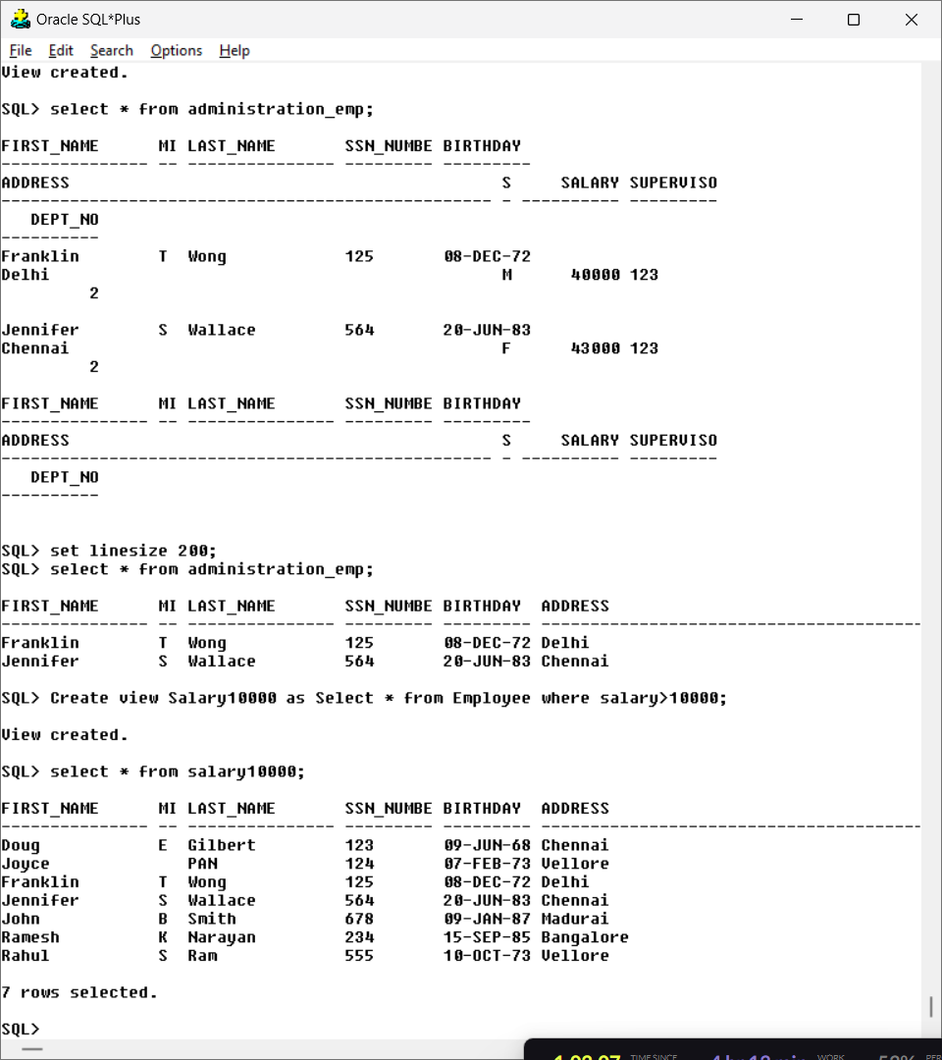

**10. Create a view to display the employee details who is working in finance or administration**

**department.**

**Query:** Create view Emp_Finance as Select * from Employee where Dept_no in (Select Dept_No from Deptt where Dept_Name = 'Finance' or Dept_Name = 'Administration');

select * from emp_finance;

**Output:**

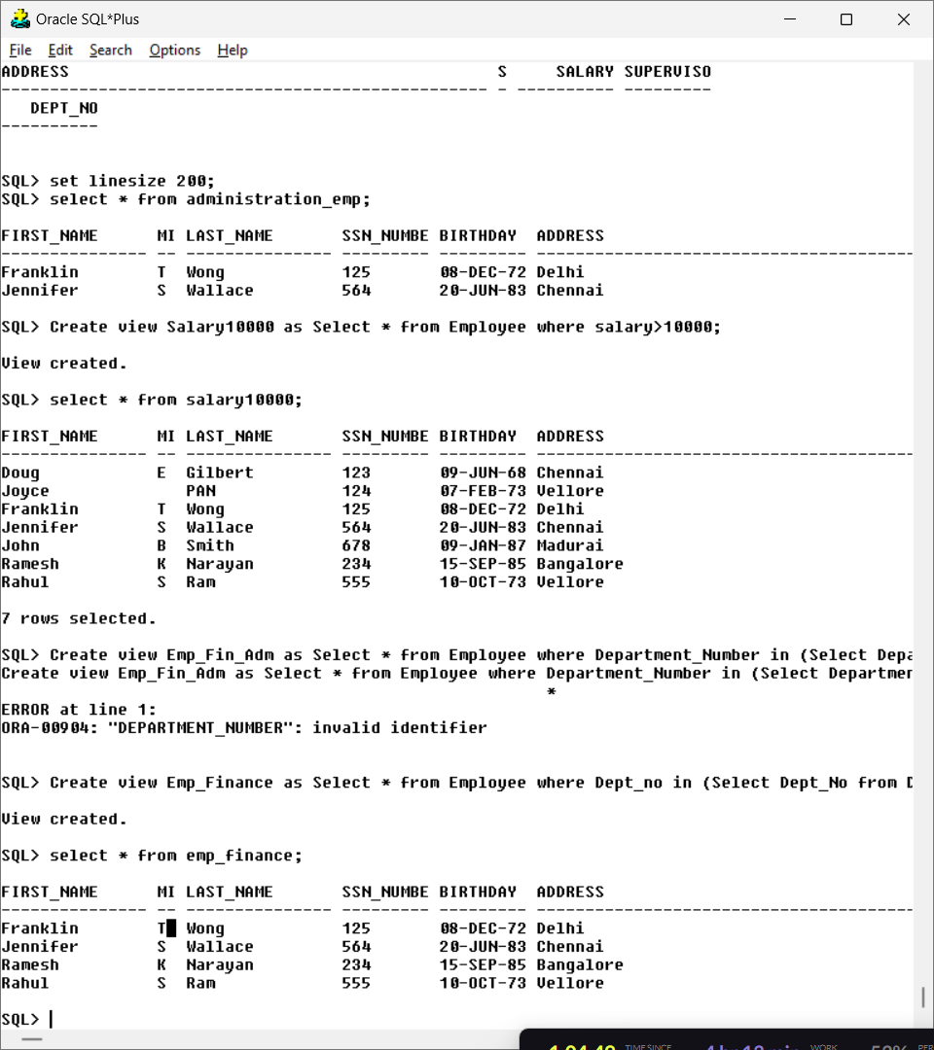

1. **Create a view to display all employees whose salary is greater than “Jennifer”.**

**Query**: Create view Salary_of_Jennifer as Select * from Employee where Salary > (Select Salary from Employee where First_Name = 'Jennifer');

Select * from Salary_of_Jennifer

**Output:**

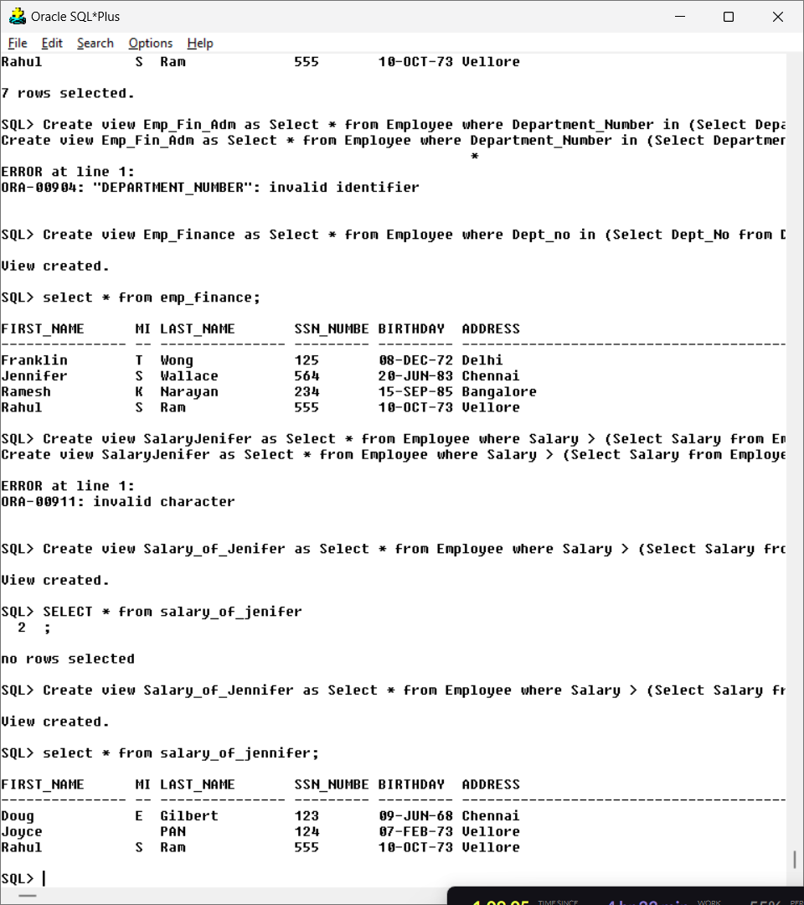

1. **Create a view to display all employees in descending order of employee first name**

**Query:** Create view First_Desc_Name as select * from Employee order by First_Name desc;

Select * from First_Desc_Name;

**Output:**

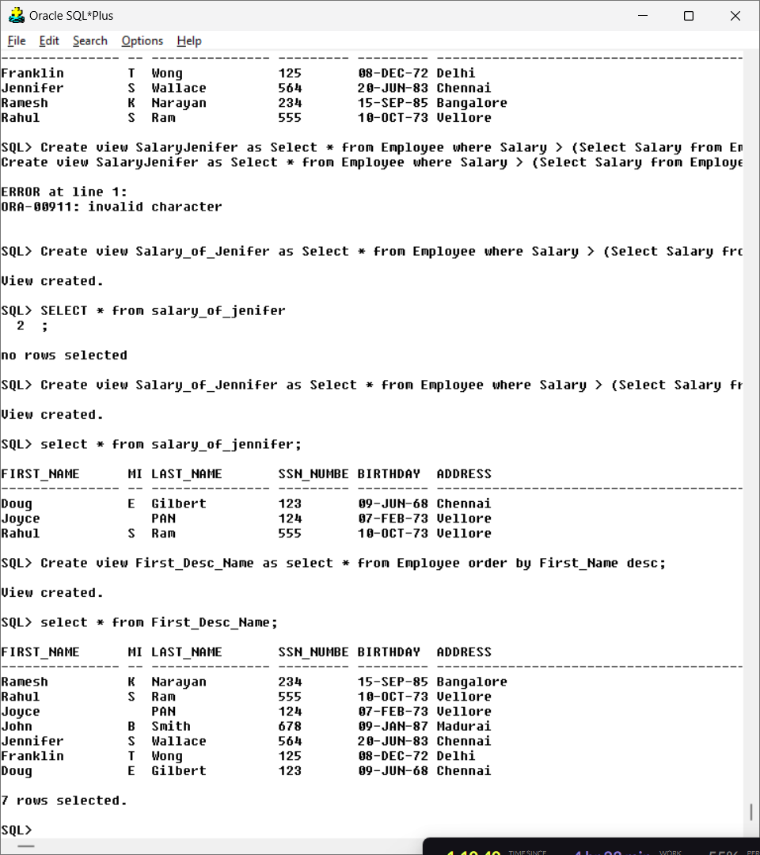

**13. Create a view to display all employees whose salary is greater than the average salary of the**

**employees.**

**Query:** Create view Salary_Greater_Avg as select * from Employee where Salary > (Select avg(Salary) from Employee);

select * from salary_greater_avg;

**Output:**

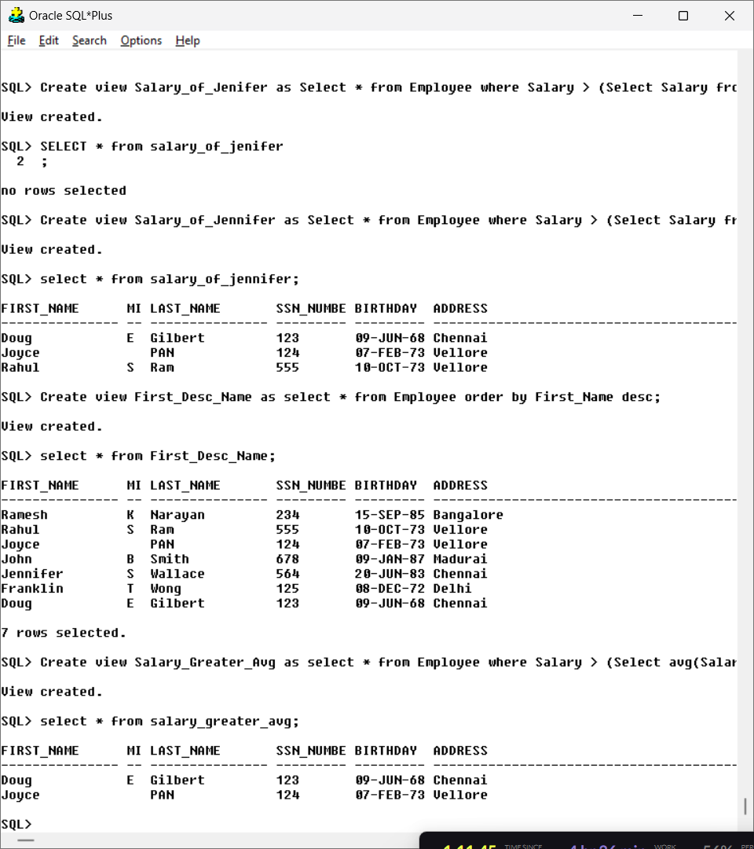

**14. Create a view to display all employees whose salary is lower than all the employees of the**

**department 1.**

**Query:** Create view Salary_Lowerthan_Dep1 as select * from Employee where Salary < (Select min(Salary) from Employee where Dept_No = 1);

Select * from salary_lowerthan_dep1;

**Output:**

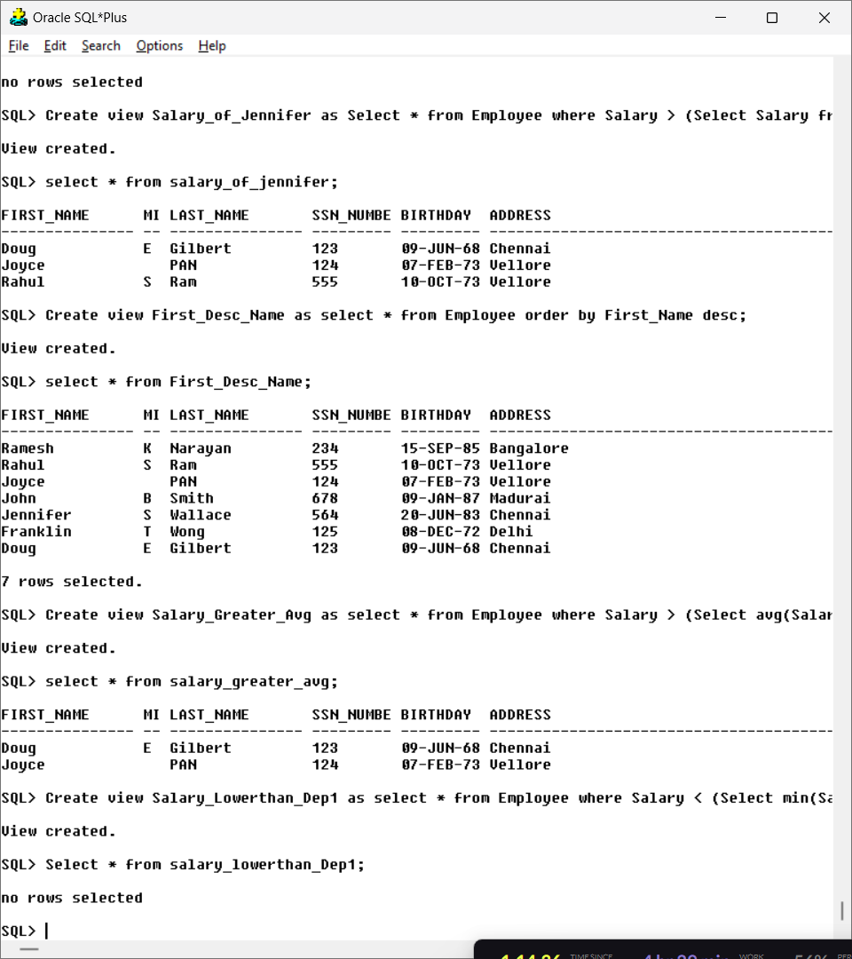

**15. Display all male employees whose salary is greater than the maximum salary of the female**

**Employees**

**Query:** Select First_Name, Salary from Employee where Sex = 'M' and salary > (Select max(Salary) from Employee where Sex = 'F');

**Output:** 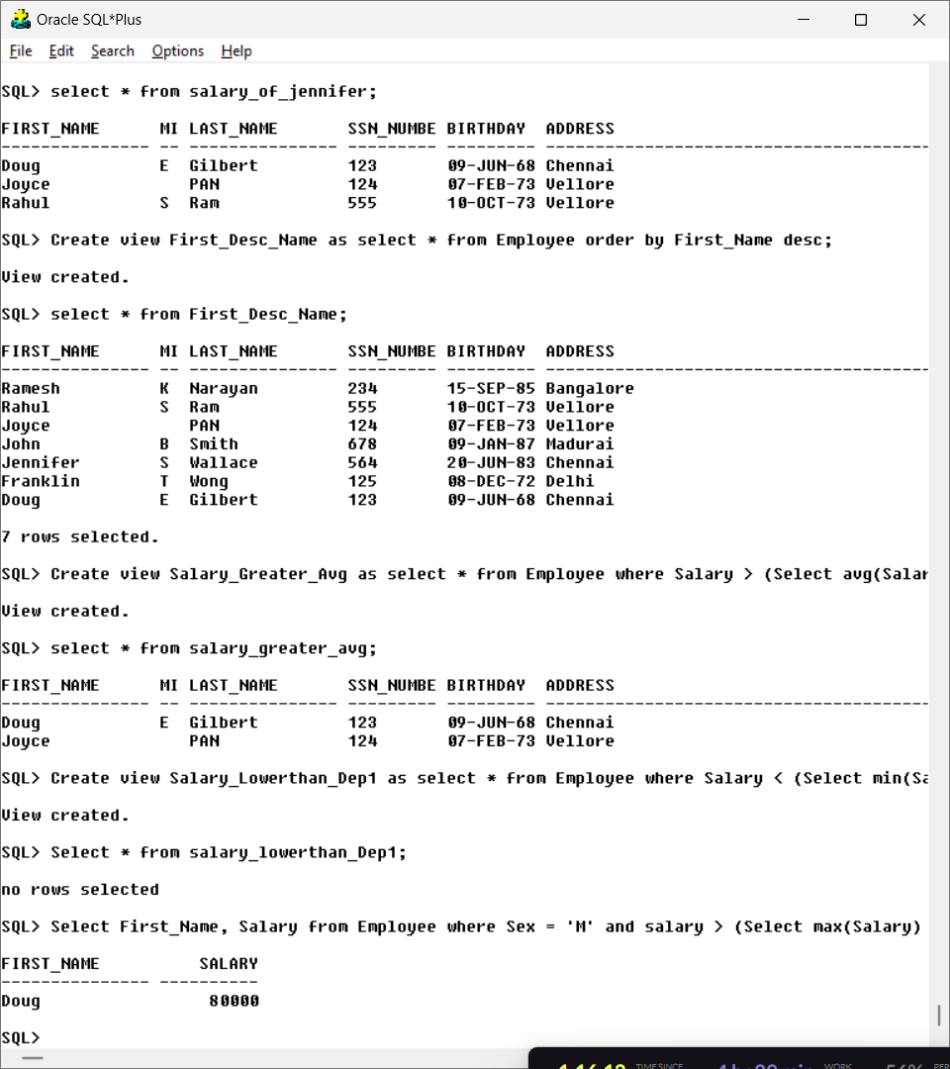

**JOINS**

**Aim: To understand how to relate and access data from multiple tables.**

**Consider the schema given in exercise 2, and execute the following queries**

1. **Find the names of all the employees who are directly supervised by ‘Joyce’.**

**Query:** Select * from Employee where Supervisor_SSN = (Select SSN_Number from Employee where First_Name = 'Joyce');

**Output:**

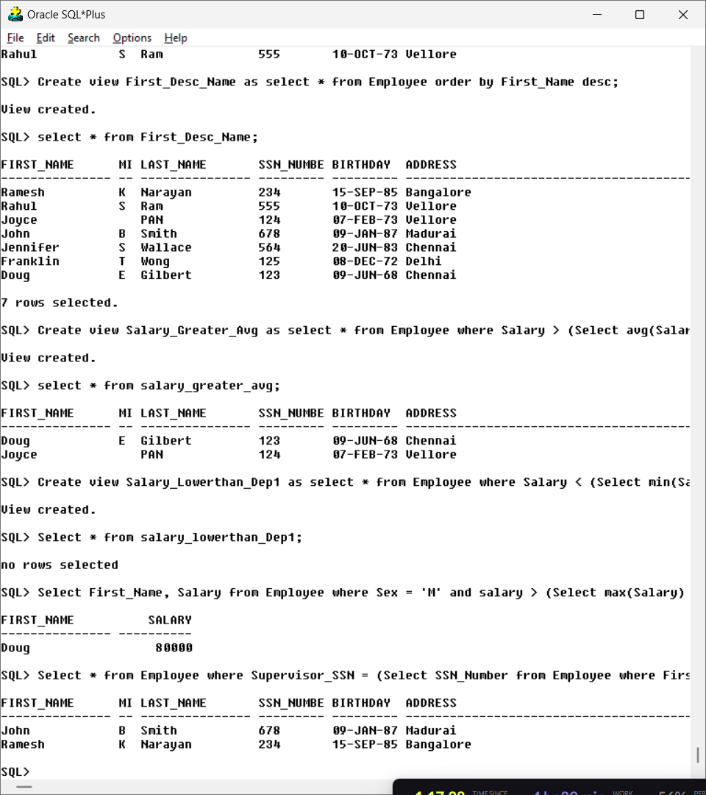

1. **Find the names of all the employees who are working in department ‘Headquarter’.**

**Query:** Select * from (Employee natural Deptt) where Dept_Name=’Headquater’;

**Output:**

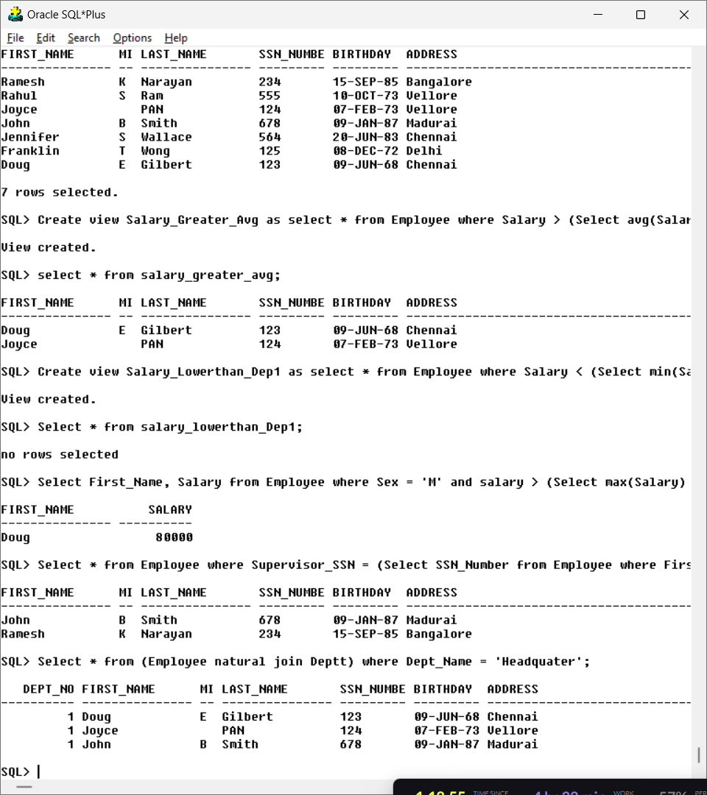

1. **List the department names and if has a manager then display the manager name too.**

**Query:** Select Dept_Name, First_Name, SSN_Number from (Deptt natural join Employee) where Employee.SSN_Number = Deptt.ManagerSSN;

**Output:**

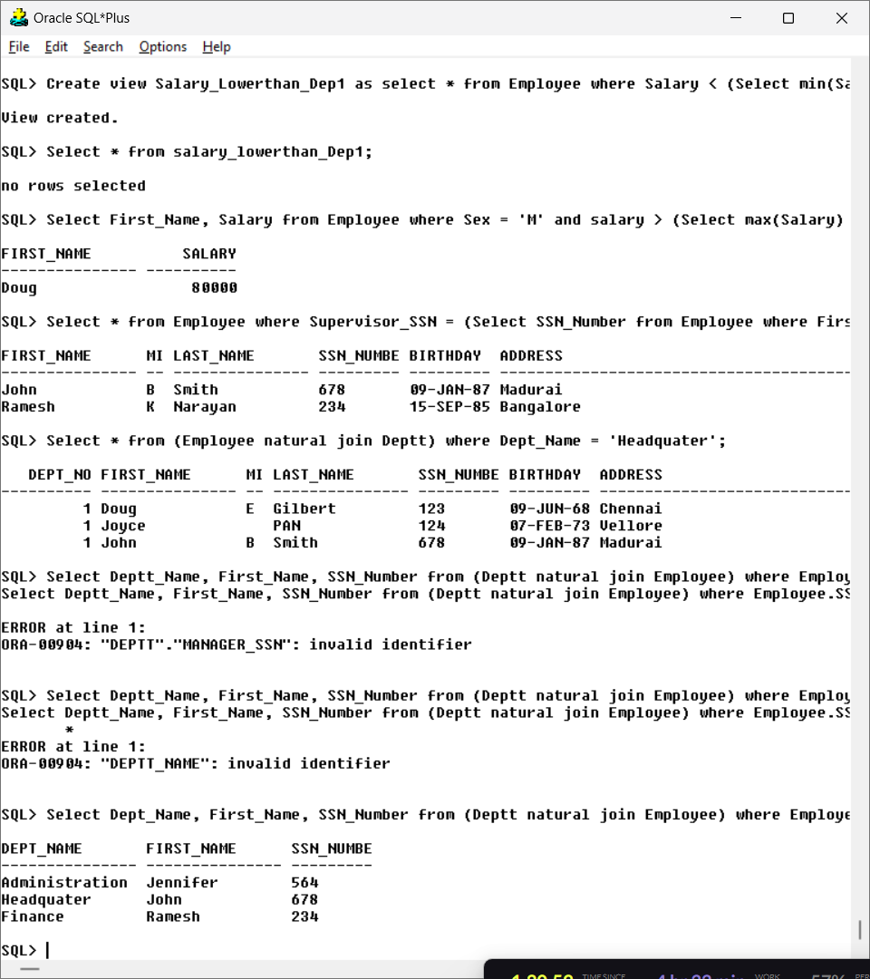

1. **Retrieve the names of the departments which have more than 2 employees.**

**Query:**

Select Dept_Name, Dept_No from Deptt where Dept_No in (Select Dept_No from Employee having count(*) > 2 group by Dept_No);

**Output:**

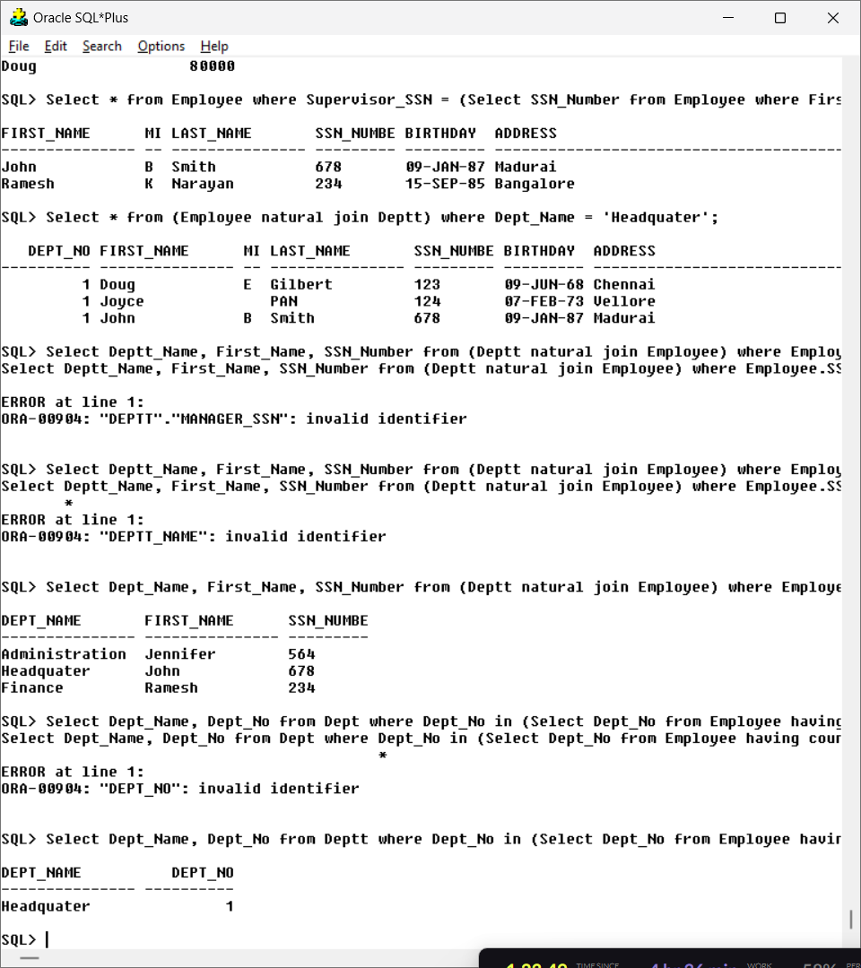

1. **Display the employee name along with the deptname and MgrSSN of that department.**

**Query:** Select First_Name, Dept_Name, ManagerSSN from (Employee natural join Deptt);

**Output:**

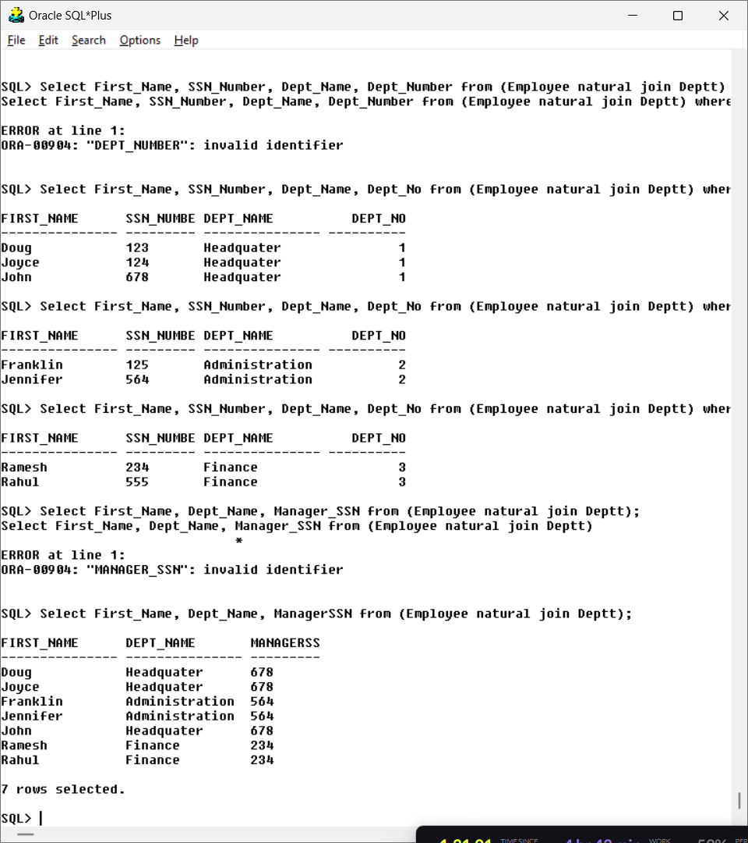

**6. Find out the ename, deptname, deptno, eno of those who are working under some department**

**number (1 or 2 or 3)**

**Query:** Select First_Name, SSN_Number, Dept_Name, Dept_No from (Employee natural join Deptt) where Dept_No = 1;

Select First_Name, SSN_Number, Dept_Name, Dept_No from (Employee natural join Deptt) where Dept_No = 2;

Select First_Name, SSN_Number, Dept_Name, Dept_No from (Employee natural join Deptt) where Dept_No = 3;

**Output:** 